CYBERSTER
Cybersecurity Training & Research

INTERNSHIP REPORT
Week 8 - Practical Lab Report
Internship Title:
Cybersecurity Analyst Intern
Project Title:
Windows Artifact Analysis
Student Name:
Duaa Bint E Adnan

Company: Cyberster
Project Supervisor: Abdullah Zia
Date: 15th August 2026

1. Introduction
This report documents the work I completed across Days 53 through 59 of Week 8 of the Cyberster Blue Team Internship. Week 8 continues Phase Two of the internship, the digital forensics phase that began in Week 7 with disk imaging, file system structure, and an initial Autopsy triage of a physical evidence source. Where Week 7 was about acquiring and examining an entire disk image, Week 8 narrows the focus onto three artefact categories that exist on every live Windows endpoint: the Security event log, the Prefetch execution record, and the thumbcache, browser cache, and Recycle Bin data that together record what was viewed and what was deleted.
The task brief frames the shift clearly. An investigator arriving at a live or recently compromised machine rarely has the luxury of a clean, pre-labelled dataset. What they actually have is a Security.evtx file containing tens of thousands of events, a Prefetch folder with hundreds of execution records, and cache and deletion artefacts scattered across the file system, the overwhelming majority of which have nothing to do with whatever they are investigating. The skill this week builds is not finding events, it is filtering out the ones that do not matter so that the ones that do matter become visible. That distinction between noise and signal is the thread running through all seven days covered in this report.
Week 8 was carried out in three connected stages, all on my own personal Windows 11 laptop rather than a provided evidence file. Days 53 to 55 (Part A) established what my own normal, physical presence at the keyboard actually looks like in the Security event log, using successful and failed logon events, legitimate privilege assignment, and background service noise. Days 56 and 57 (Part B) moved from who logged in to what actually ran, using Prefetch to build an execution history and search for activity from suspicious locations. Days 58 and 59 (Part C) closed the investigation by looking at what was viewed, through thumbcache and browser cache, and what had been deleted, through the Recycle Bin. Each stage builds directly on the baseline the previous stage established, and the report is structured to read as one continuous investigation rather than three separate assignments, since that is genuinely how the work was carried out.
Every finding in this report is drawn from evidence I actually collected and screenshotted during this investigation. Because all three parts involve my own personal machine, I redacted or blurred personal filenames, personal thumbnail images, and private URLs before including any screenshot, in line with the brief’s privacy requirement. Where the evidence did not fully answer a question the brief raised, or where a tool or technique had a genuine limitation, that gap is stated directly in the relevant section rather than filled in or glossed over.

2. Investigation Objectives
The task brief set out a specific set of goals across the three parts of Week 8, and I have kept these as the objectives for this report rather than simply restating the brief itself:
- Establish a baseline of my own normal, physical, interactive authentication activity on this machine, so any future logon pattern can be compared against a known-good reference rather than judged in isolation.
- Analyse both successful and failed authentication events, and understand what a failure code actually indicates about the cause of a failed logon, rather than treating any failure as inherently suspicious.
- Investigate how administrative privilege is assigned on this machine through Event ID 4672, and practise tying a log entry back to a real, explainable cause rather than accepting it at face value.
- Distinguish human-driven authentication from the authentication Windows generates on its own behalf, so background service accounts are recognised for what they are rather than flagged as unknown activity.
- Parse the Prefetch directory into a structured dataset, identify the twenty most frequently executed programs, and assess each against what is expected on a normal Windows system.
- Search the full Prefetch dataset for execution from locations that are not standard Windows system paths, since execution location is one of the most reliable indicators of malicious activity in prefetch data.
- Build a seven-day execution timeline and correlate it against the event log baseline from Days 53 to 55.
- Locate, copy, and parse the thumbcache database files, and extract a representative sample of thumbnail content while handling personal image data responsibly.
- Identify every browser installed on this machine, extract and document what was cached and when.
- Walk through every entry in this account’s Recycle Bin folder, recovering the original file path, deletion timestamp, and file data status for each one.
- Correlate findings across all three artefact categories, event logs, Prefetch, and cache/thumbcache/Recycle Bin, so the case rests on multiple independent artefacts agreeing with each other rather than any single source.
Each objective builds toward the same outcome: by the end of Day 59 I should be able to look at an unfamiliar event, execution record, or deletion entry on a machine I do not know, and reason about whether it fits a normal pattern or warrants a closer look, using the same layered logic developed here against my own known-good machine.

3. Investigation Environment and Methodology
All work in this report was carried out on my own Windows 11 laptop, using an elevated PowerShell session throughout, since reading the live Security.evtx file, the Prefetch directory, the thumbcache database files, and the Recycle Bin folder all require administrator rights. Rather than analysing any of this data live, I followed the same evidence-handling discipline established in Week 7: I made a working copy of each artefact before touching it, generated a cryptographic hash where the artefact type made that meaningful, and only ever filtered or parsed the copy.

3.1 Evidence Handling and Working Copies
Every artefact category in this investigation was copied into its own dedicated working folder before any parsing began: C:\Forensics\EventLogs for the Security log, C:\Forensics\Prefetch for the Prefetch directory, and C:\Forensics\Thumbcache, C:\Forensics\BrowserCache, and C:\Forensics\RecycleBin for the Day 58 to 59 artefacts. This is the same principle behind write-blocking and hash verification from the Week 7 disk-imaging exercise, applied here to a live endpoint rather than a static image: the act of investigating should not be able to alter the evidence, and the evidence should have a fixed reference point that later filtering and tool errors cannot silently change.
For the Security event log specifically, I generated a SHA-256 hash of the copied Security.evtx immediately after copying it, which is documented in Section 4.1. Prefetch, thumbcache, and Recycle Bin artefacts consist of many small files rather than one large file, so instead of a single hash I recorded and independently verified file counts at each stage (460 prefetch files copied, thirteen thumbcache databases copied, nineteen Recycle Bin entries confirmed by two separate counting methods), which serves the same evidentiary purpose of giving a fixed, checkable baseline for the dataset.

3.2 Tools Used Across the Week
Each artefact category required its own parsing tool, since none of them share a common file format:
- EvtxECmd, from Eric Zimmerman’s EZ Tools suite, to parse the binary EVTX Security log into structured CSV output.
- PECmd, also from EZ Tools, to parse the binary .pf Prefetch files into structured CSV output, including an automatically generated timeline CSV.
- Thumbcache Viewer, obtained from its official developer repository, to parse and export thumbnails from the thumbcache database files.
- ChromeCacheView, obtained directly from its developer’s own site, to parse Chrome’s cache, and again pointed at Edge’s Chromium-based cache folder when NirSoft’s dedicated Edge utility was unreachable.
- A short custom PowerShell script, using ReadAllBytes and BitConverter, to parse the Recycle Bin’s binary $I metadata files directly against their fixed byte layout, since no existing EZ Tool or NirSoft utility reads this format.
PowerShell itself, using Import-Csv and Where-Object against the tool-generated CSVs, was the constant across every stage of the week for the actual filtering and analysis work, for reasons explained directly below.

3.3 The Excel Online Data-Handling Problem, and Why I Used PowerShell Throughout
My original plan for the Day 53 event log data was to open the parsed CSV directly in Excel for filtering, the same way I worked with spreadsheet data in Week 7. In practice this caused a real problem worth documenting honestly rather than hiding: because my local desktop Excel installation is outdated and cannot save changes, I switched to Excel Online. Opening the CSV there, Excel’s automatic column-type detection misread the TimeCreated column, silently stripping the date portion and keeping only the time-of-day fraction, so a value that should have read as a full date and time displayed instead as an obviously wrong date such as 1900-01-00. Worse, because the file was opened through OneDrive, Excel Online’s autosave overwrote the original CSV with this corrupted interpretation, meaning the mistake had actually damaged the saved file rather than just being a display issue confined to my screen.
I resolved this by regenerating a fresh CSV from the original hash-verified EVTX, naming it SecurityParsed_v2.csv to avoid ever touching the corrupted file again, and verifying the raw values directly with PowerShell’s Get-Content before letting any spreadsheet application near the data again.
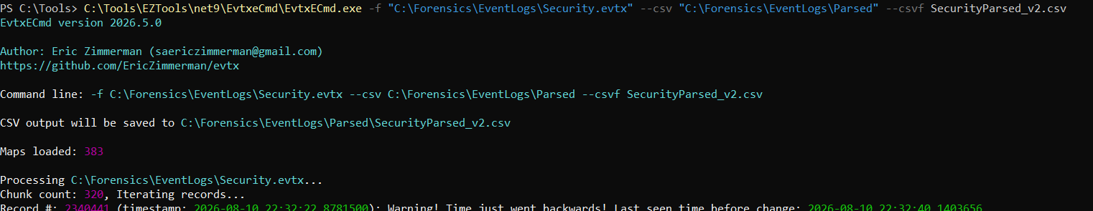
Figure 1: Regenerating a fresh, uncorrupted CSV (SecurityParsed_v2.csv) with EvtxECmd after the Excel Online autosave corrupted the first export; the EvtxECmd "time just went backwards" warning is also visible here.
Rather than continuing to fight Excel Online’s auto-parsing, I moved all actual filtering and analysis work for the remainder of the week into PowerShell, using Import-Csv and Where-Object against the clean, untouched CSVs. This turned out to be a genuine improvement rather than just a workaround: every filter used anywhere in this report, across the event log, Prefetch, and cache analysis, is a scripted, repeatable PowerShell command rather than a manual point-and-click spreadsheet filter, which is a more defensible and reproducible methodology for forensic work in the first place. By Days 58 and 59 this had become the default approach rather than a reaction to a specific incident: the Recycle Bin’s $I files are not text or CSV at all, and no spreadsheet application could meaningfully open a file containing a fixed binary header, an eight-byte FILETIME timestamp, and a UTF-16 path string. Reading it correctly required a script that understands the byte layout, which is precisely what PowerShell’s ReadAllBytes and BitConverter functions are built for, so by that stage Excel was never a candidate tool to begin with rather than one I was actively avoiding.

3.4 Overall Methodology Summary
The evidence path followed the same shape across all three parts of the week: copy the live artefact into a dedicated working folder, establish a fixed reference point through hashing or file-count verification, parse the copy into a structured format with the appropriate EZ Tools or NirSoft utility, confirm the resulting schema on sample records before filtering at scale, carry out all filtering and analysis in PowerShell rather than a spreadsheet application, and correlate the findings against the artefact categories already investigated earlier in the week. That progression, event logs establishing who was authenticated and when, Prefetch establishing what actually ran, and thumbcache, browser cache, and the Recycle Bin establishing what was viewed and deleted, is the backbone of the rest of this report.

4. Windows Security Event Log Analysis
Part A of Week 8 is built around one machine, my own laptop, and one artefact, its live Security.evtx. Day 53 establishes what my own normal, physical presence at the keyboard actually looks like in the log, using successful and failed logon events. Day 54 looks at how administrative privilege is legitimately assigned on this machine, using the Special Privileges Assigned event. Day 55 catalogues the background noise Windows generates on its own, the service accounts that log on constantly without any human involvement at all, so that noise can be recognised and set aside with confidence rather than mistaken for something suspicious.

4.1 Evidence Preparation and Parsing
Working from an elevated terminal, I created a dedicated working folder and copied the live log into it rather than opening the original in place, then generated a SHA-256 hash of the copy immediately:
mkdir C:\Forensics\EventLogs
copy C:\Windows\System32\winevt\Logs\Security.evtx C:\Forensics\EventLogs\Security.evtx
Get-FileHash C:\Forensics\EventLogs\Security.evtx -Algorithm SHA256
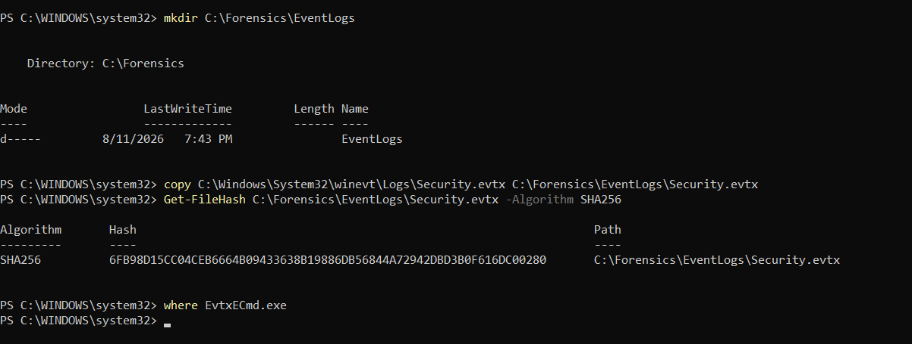
Figure 2: Working folder creation, evidence copy, and SHA-256 hash generation of the copied Security.evtx.
The resulting SHA-256 hash of the evidence copy is:
6FB98D15CC04CEB6664B09433638B19886DB56844A72942DBD3B0F616DC00280
This hash matters for the same reason a hash mattered during the Week 7 disk acquisition: it is the fixed point everything downstream of this exercise can be checked against. Every subsequent step in this section, parsing, filtering, and analysis, was performed against this specific, hash-verified copy rather than the live log.
EVTX is a binary format, so the copied log needed to be converted into a structured, filterable format before any real analysis could begin. I used EvtxECmd, retrieved through the official Get-ZimmermanTools.ps1 downloader into C:\Tools\EZTools:
C:\Tools\EZTools\net9\EvtxeCmd\EvtxECmd.exe -f "C:\Forensics\EventLogs\Security.evtx" --csv "C:\Forensics\EventLogs\Parsed" --csvf SecurityParsed.csv
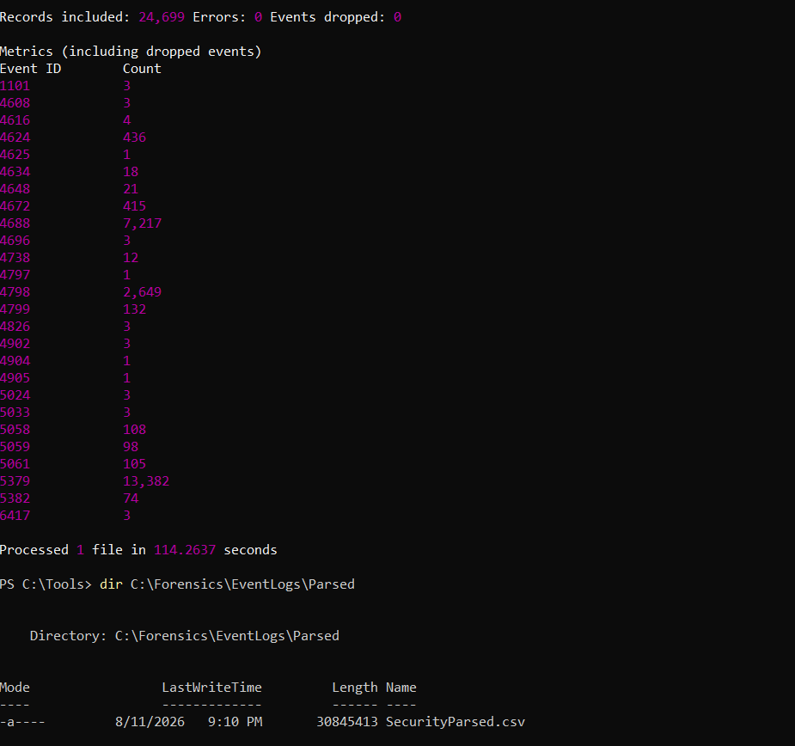
Figure 3: EvtxECmd completion summary: 24,699 records included, 0 errors, 0 events dropped, processed in 114.26 seconds, with a per-Event-ID metrics breakdown.
EvtxECmd processed the entire copied log cleanly, with zero errors and zero dropped events, which is itself a small but useful confirmation that the copy operation had not damaged the file. The per-Event-ID metrics table it produced was genuinely useful before any filtering began, since it gave an immediate sense of scale: 436 instances of Event ID 4624 (successful logon), only 1 instance of 4625 (failed logon), 415 instances of 4672 (special privileges assigned), and a much larger 7,217 instances of 4688 (process creation), among many others. Knowing these counts in advance meant I could sanity-check every later filter result against a known total rather than filtering blind.
One line in this output was worth flagging rather than ignoring: EvtxECmd printed a warning that "time just went backwards" partway through parsing, at record 2,340,441, noting the last seen timestamp before the change (visible in Figure 1 above). This indicates that somewhere in the log, events are not in strictly ascending chronological order, which typically points to either a system clock adjustment or multiple log-writing sources being interleaved. I was not able to fully resolve the cause of this within the scope of this baseline exercise, and it is recorded again as an open observation in Section 10.
The Excel Online corruption problem described in Section 3.3 occurred at this stage of the investigation, and its resolution is documented there rather than repeated here. Once I confirmed the exact CSV schema by inspecting sample records directly, I established that EvtxECmd’s structured output places the target account under PayloadData1, the numeric logon type as text such as "LogonType 5" under PayloadData2, and the LogonId under PayloadData3 for 4624 and 4625 events. Every filter described in Sections 4.2 through 4.5 is built on that confirmed field mapping.

4.2 Human Authentication Baseline (Day 53)
Before an analyst can say a logon pattern looks abnormal, they need a working definition of what normal looks like for the specific account and machine in question. Day 53’s purpose was to build exactly that: a baseline of my own physical, interactive presence on this laptop, built entirely from the Security log rather than from memory.
Event ID 4624 records every successful logon on the system, but a raw 4624 count is close to useless on its own, since the event fires for an enormous range of causes: a human unlocking their screen, a background service authenticating to run a task, a scheduled task waking up, and more. My first filtering decision was therefore to isolate 4624 and then further filter on Logon Type, since that field is what actually distinguishes a human sitting at the keyboard from Windows authenticating on its own behalf. Out of 436 total 4624 events in the 48-hour window I examined, only a small subset carried the logon types relevant to physical, human presence.
Logon Type 2 represents an interactive logon at the physical console, including a fresh cold boot into a new session. In my own data, Type 2 events did not appear tied to my own account name directly. Instead, every Type 2 event I found was tied to two specific built-in identities: Font Driver Host\UMFD-0 / UMFD-1, and Window Manager\DWM-1. This is expected Windows behaviour rather than a gap in the data: UMFD (User-Mode Font Driver Host) and DWM (Desktop Window Manager) are per-session helper processes that Windows spins up automatically the moment an interactive session actually starts or resumes, to handle font rendering and desktop compositing respectively. Both consistently appeared in tight clusters, four events within a fraction of a second of each other, and crucially, each cluster’s timestamp lined up almost exactly with a Type 7 unlock event immediately following it. I am treating these Type 2 clusters as corroborating evidence that a real interactive session boundary occurred at that moment, not as separate logons performed by me.
Logon Type 7 fires when a locked workstation is unlocked, and this is where my actual human activity was clearly visible in the data. Every single Type 7 event in the 48-hour window was tied to MicrosoftAccount\duaadnan45@gmail.com, my own account, and nothing else. This is the strongest and cleanest signal in the entire dataset for physical presence: an unlock event can only be generated by someone who already has valid credentials for the session, entering them at the lock screen.
The table below lists every Type 7 unlock event recorded for my account within the last 48 hours of the copied log, in chronological order. Where a Type 2 UMFD/DWM cluster occurred at essentially the same timestamp as an unlock, I have noted it as corroboration rather than listing it as a separate row, since it reflects the same session boundary rather than an additional session.
Table 1: Human working-hours session timeline, derived from Logon Type 2 and Type 7 events over the last 48 hours of the copied Security log.
Date | Time (log time) | Logon Type | Account | Interpretation
2026-08-10 | 19:01:54.98 | 7 (Unlock) | duaadnan45@gmail.com | Session resumed.
2026-08-10 | 22:16:20.92 | 7 (Unlock) | duaadnan45@gmail.com | Session resumed; UMFD/DWM Type 2 cluster at 22:16:11 immediately precedes it.
2026-08-10 | 22:21:45.80 | 7 (Unlock) | duaadnan45@gmail.com | Session resumed; UMFD/DWM Type 2 cluster at 22:21:11 immediately precedes it.
2026-08-10 | 23:17:03.15 | 7 (Unlock) | duaadnan45@gmail.com | Session resumed; UMFD/DWM Type 2 cluster at 22:32:39 corresponds to the preceding lock/unlock cycle.
2026-08-11 | 13:01:25.72 | 7 (Unlock) | duaadnan45@gmail.com | Session resumed 5 seconds after a failed-logon (4625) artefact; see Section 4.3.
2026-08-11 | 14:34:18.58 | 7 (Unlock) | duaadnan45@gmail.com | Final unlock captured within the copied log window.
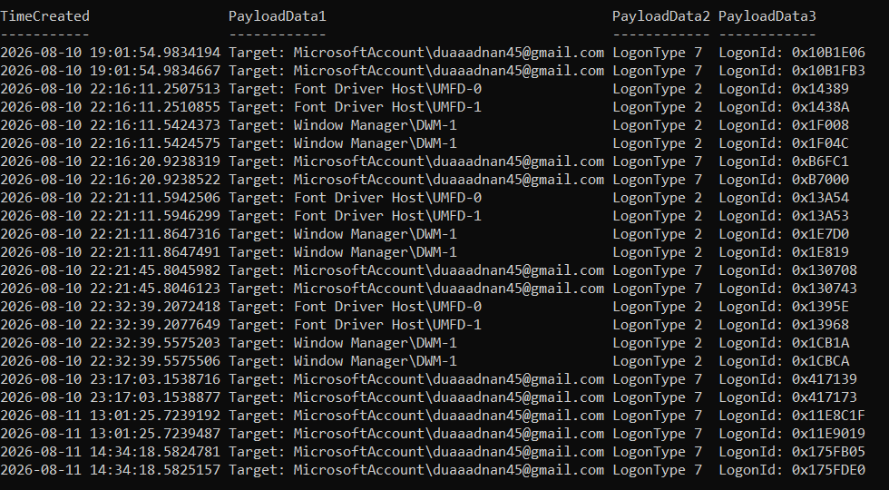
Figure 4: PowerShell Format-Table output of every Logon Type 2 and Type 7 event for the last 48 hours, sorted chronologically, showing the UMFD/DWM Type 2 clusters and the duaadnan45@gmail.com Type 7 unlock events used to build the baseline table above.
Read together, this pattern is exactly what a normal, single-user laptop should look like: six clearly spaced unlock events across roughly nineteen and a half hours, spanning an evening session on 10 August into the following afternoon on 11 August, each one corroborated by the UMFD/DWM session-start noise a few seconds earlier. There is no indication of concurrent sessions, no unlock events tied to any account other than my own, and no unlock happening at a time inconsistent with a person plausibly being at their own machine. This is now my working definition of normal physical presence on this laptop, and it is the baseline the rest of this investigation should be compared against.

4.3 Failed Authentication Activity
Event ID 4625 records a failed logon attempt, and it matters to an investigator because a cluster of failures, especially against different accounts or from an unfamiliar source, is one of the clearest signatures of a password-guessing or brute-force attempt. My log contained exactly one 4625 event within the window examined, which meant I did not need to intentionally trigger extra failures as the brief allows for when no failures are present.
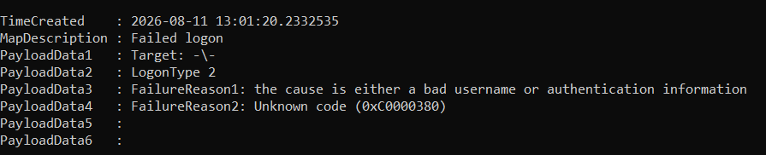
Figure 5: The single Event ID 4625 record captured in the copied log, showing the timestamp, blank target account, Logon Type 2, and the two failure-reason payload fields.
The event recorded a timestamp of 2026-08-11 13:01:20.2332535, Logon Type 2, a blank target account rather than a real username, and a failure reason describing the cause as "a bad username or authentication information" with an underlying status/sub-status pairing of 0xC000006D / 0xC0000380. I looked this specific status and sub-status pair up rather than assuming it meant a mistyped password, since the sub-status EvtxECmd’s own map file listed as an "unknown code" was worth verifying independently.
The 0xC000006D / 0xC0000380 combination, together with a blank account name, a SYSTEM-owned Logon Process of User32, and Logon Type 2, is a documented Windows artefact associated with the screen lock and wake transition, sometimes visible to users as a brief black screen immediately after waking or unlocking a machine. It is not the signature of someone actually mistyping a password against a real account; a genuine bad-password attempt against my account would show my own username in the Account For Which Logon Failed field rather than a blank one.
This interpretation is directly corroborated by the timeline itself: the failed logon fired at 13:01:20, and my own successful Type 7 unlock for duaadnan45@gmail.com fired only five seconds later at 13:01:25. Rather than a separate, unexplained failed login attempt, this reads as a single unlock transition that produced both a transient, self-resolving OS-level failure artefact and the genuine successful unlock immediately after it. This event alone would not be sufficient to indicate malicious activity, and within the context of this baseline investigation, it is consistent with a benign, self-generated artefact rather than a credential-guessing attempt. This same window is independently corroborated from a completely different artefact type in Section 5.5.
Day 53 established a clear, evidence-based baseline of my normal interactive activity on this machine: six Type 7 unlock events tied exclusively to my own account across a roughly nineteen-and-a-half-hour window, each corroborated by a matching UMFD/DWM Type 2 cluster marking the same session boundary. The single 4625 failure present in the log was not left unexplained; researching its specific status/sub-status codes and correlating it against the unlock five seconds later identified it as a known, benign Windows lock-screen artefact rather than a real authentication failure.

4.4 Privilege and UAC Activity
Privilege escalation is one of the core techniques an attacker relies on once they have an initial foothold on a system, since a standard user account is of limited use without administrative rights. Day 54’s purpose was to look at how administrative privilege is legitimately assigned on my own machine, using Event ID 4672, so that legitimate privilege use has a known shape before I ever have to judge whether an unfamiliar instance of the same event looks legitimate or not.
Event ID 4672 fires whenever a logon session is granted a defined list of sensitive privileges, things like SeDebugPrivilege, SeBackupPrivilege, and SeTakeOwnershipPrivilege, that are normally reserved for administrator-level accounts. My log contained 415 instances of 4672 within the metrics EvtxECmd reported. On inspection, the privilege list itself was identical, essentially boilerplate, across every 4672 event, which meant the actual analytical value was not in what privileges were granted but in when each event happened and what account and process it was tied to.
I identified the accounts receiving Type 4672 events with a unique-value query, which returned five distinct identities: NT AUTHORITY\SYSTEM, NT AUTHORITY\LOCAL SERVICE, NT AUTHORITY\NETWORK SERVICE, Window Manager\DWM-1, and MicrosoftAccount\duaadnan45@gmail.com, my own account. I then cross-referenced specific timestamps from each category against the surrounding Event ID 4688 process-creation activity to establish, wherever possible, an explainable cause rather than simply accepting the event at face value.
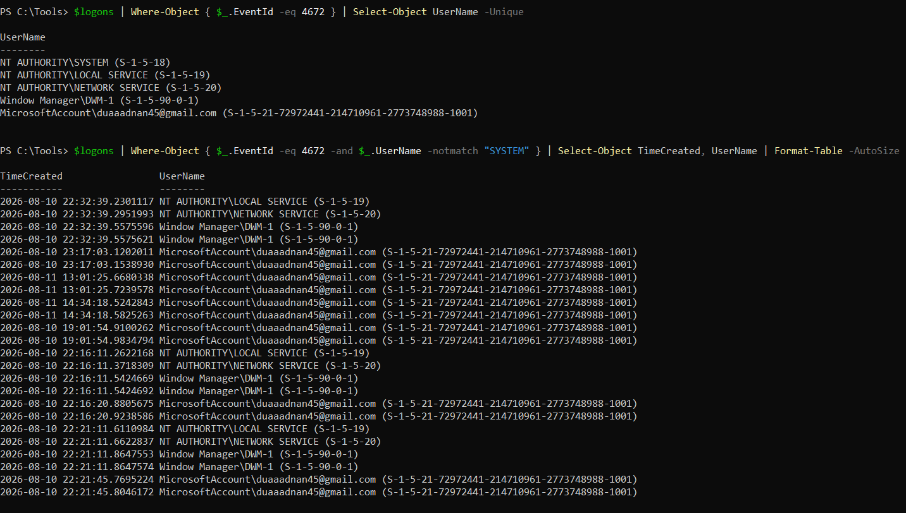
Figure 6: Unique accounts receiving Event ID 4672 across the log, and the filtered list of non-SYSTEM 4672 events, used to identify which timestamps to cross-reference against process-creation activity.
Table 2: Privilege event analysis: the task brief’s required minimum of three Event ID 4672 examples, each cross-referenced with an explainable cause.
No. | Timestamp | Account | Associated Activity | Analyst Interpretation
1 | 2026-08-10 22:21:46 | NT AUTHORITY\SYSTEM | Coincides exactly with a burst of Event ID 4688 process-creation events for services.exe, svchost.exe, winlogon.exe, userinit.exe, and sihost.exe | Consistent with the normal Windows startup / logon sequence assigning SYSTEM its standard privilege set. Not tied to a specific user action, but explainable as core OS behaviour.
2 | 2026-08-11 13:01:25 | MicrosoftAccount\duaadnan45@gmail.com | Same timestamp as the Type 7 unlock in Section 4.2, five seconds after the 4625 lock-screen artefact | Routine assignment of the account’s standard privilege set on interactive session resume. My account has local administrative rights, so this token assignment happens automatically on every unlock rather than indicating a distinct elevation action.
3 | 2026-08-10 22:32:56 | NT AUTHORITY\SYSTEM | Tied to wazuh-agent.exe repeatedly spawning auditpol.exe as a child process (see Figure 8) | The Wazuh SIEM agent deployed during Weeks 1–6 of the internship performing a periodic audit-policy verification check. A legitimate, explainable elevated action from a known, previously deployed monitoring tool, not user-driven, but genuinely accountable.
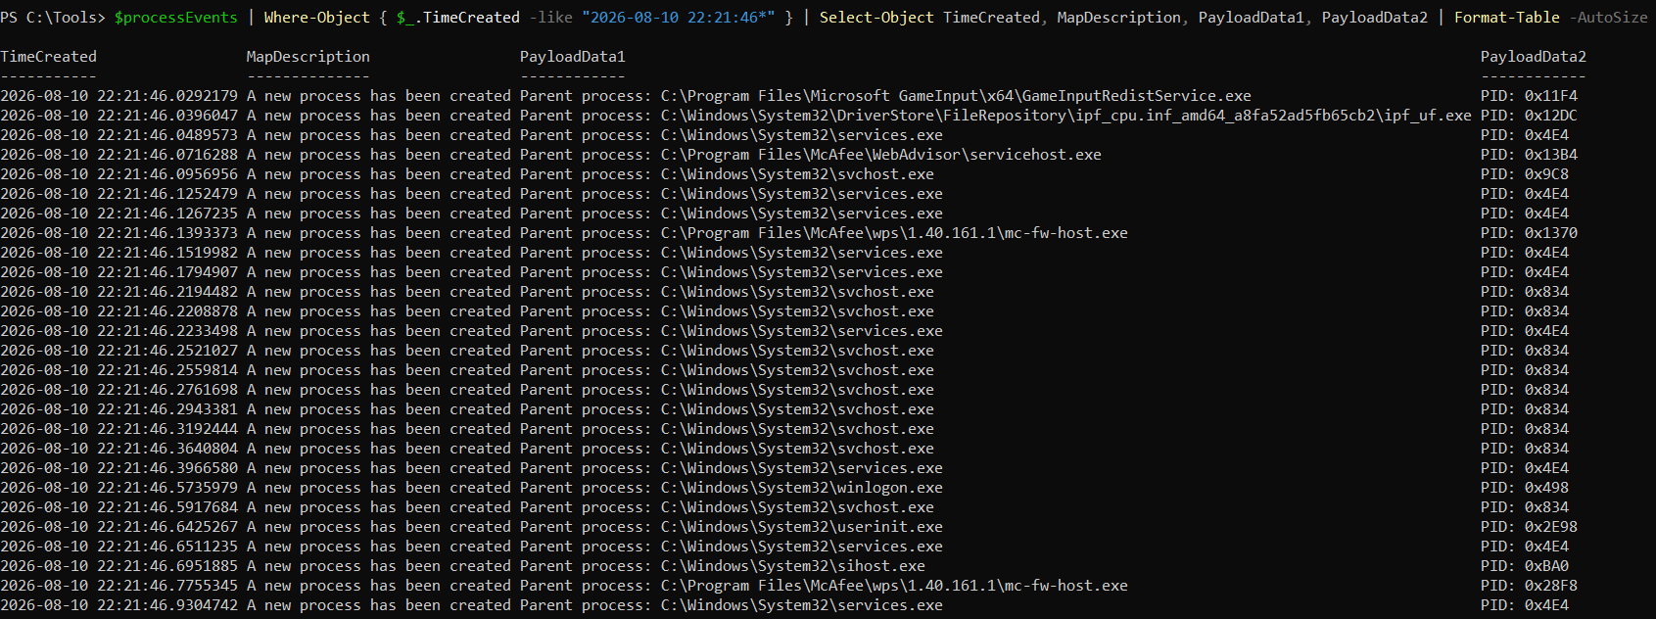
Figure 7: Event ID 4688 process-creation records at 22:21:46, showing services.exe, svchost.exe, winlogon.exe, userinit.exe, and sihost.exe spawning in the same second as the SYSTEM 4672 cluster, the correlation supporting Entry 1 in the table above.
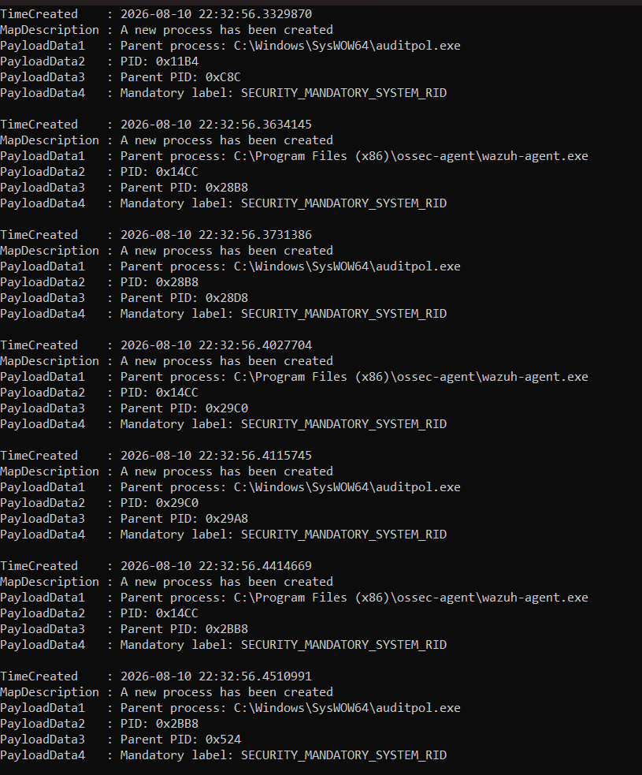
Figure 8: Event ID 4688 records showing wazuh-agent.exe repeatedly spawning auditpol.exe, correlated with the SYSTEM 4672 event at 22:32:56, the basis for Entry 3 in the table above.
The task brief specifically asks for 4672 events tied to actions like installing software, opening an administrator command prompt, or clicking Yes on a UAC prompt. I want to be transparent that the copied log window did not capture a clean, isolated example of any of those three specific triggers. I checked directly for this: searching every 4688 record for any process named powershell.exe, WindowsTerminal.exe, or consent.exe (the process Windows uses to render the UAC elevation prompt) returned many PowerShell parent-process events, but I subsequently confirmed that the copied log snapshot itself ends at 2026-08-11 14:43:37, well before I opened today’s own elevated PowerShell session at approximately 19:43 to carry out this exercise. That means the most obvious, literal example of "me opening an administrator terminal" falls entirely outside the evidence window I actually captured, rather than being absent from the machine’s real activity.
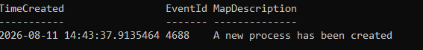
Figure 9: The most recent event in the copied log, timestamped 2026-08-11 14:43:37, confirming the exact end of the evidence window and explaining why this session’s own elevated-terminal activity is not represented in the analysis above.
Given that constraint, the three entries documented above represent the strongest, most honestly explainable privilege events actually present within the captured window: one tied to the OS boot sequence, one tied to my own account’s routine unlock-time privilege assignment, and one tied to a legitimate, previously deployed monitoring agent performing a scheduled check. None of these represents a case of me clicking through a UAC dialog specifically, but each one is a real, correlated, and non-speculative explanation rather than an unexplained privilege event, which better serves the underlying goal of the exercise, learning to explain a 4672 event rather than just locating one, than forcing a fit to a category the evidence does not actually contain.
More broadly, the distinction the brief is really building toward is this: legitimate administrative activity is 4672 events that correlate cleanly with an identifiable, explainable process or account behaviour, whether that is a boot sequence, an unlock, an installer, or a known agent. Potentially suspicious privilege activity would instead look like a 4672 event tied to an account that should not have administrative rights, occurring at a time with no corroborating logon or process activity, or immediately followed by unusual process creation with no legitimate parent. None of the 415 4672 events in this log showed that second pattern.
Working through the privilege-audit exercise made clear that Event ID 4672 on its own tells an analyst almost nothing, since the privilege list attached to it barely varies between events. The actual investigative work is entirely in correlation: pairing a 4672 timestamp against 4688 process-creation data, or against a known logon event, is what turns a bare privilege-assignment record into an explainable finding. I also learned a genuinely useful lesson about evidence scope from the fact that this session’s own activity fell outside my copied log window: a forensic snapshot only tells you what happened up to the moment it was taken, and an investigator has to be explicit about that boundary rather than assuming a log necessarily contains everything relevant to their current question.

4.5 Background System Noise
Background service authentication generates by far the largest share of routine activity in a Windows Security log, and if an analyst does not have a confident, specific understanding of what this activity normally looks like, they risk either drowning in false positives or, worse, becoming numb to the noise and missing something that is genuinely relevant hidden inside it. Day 55’s purpose was to catalogue this background activity specifically enough that it can be recognised and set aside with confidence.
Logon Type 5 represents a service logon: an account authenticating specifically so that a Windows service can run, rather than any human interaction taking place. Filtering my 436 total 4624 events down to only Logon Type 5 returned a large, tightly clustered set of entries, none of which were tied to my own account or any account I created myself.
Figure 10: Unique accounts observed with Logon Type 5 in the parsed Security log: NT AUTHORITY\SYSTEM, NT AUTHORITY\LOCAL SERVICE, and NT AUTHORITY\NETWORK SERVICE.
Exactly three distinct built-in accounts appeared under Logon Type 5 in my evidence: SYSTEM, LOCAL SERVICE, and NETWORK SERVICE. I have not included DWM or UMFD in the table below even though the brief mentions them as likely examples, because in my own data those two identities consistently appeared under Logon Type 2, tied to interactive session start as discussed in Section 4.2, not under Logon Type 5; I would rather report the account types exactly as they actually occurred in my evidence than pad the table with examples that did not appear in this log under this specific logon type.
Table 3: Background account analysis: the three built-in accounts identified under Logon Type 5, satisfying the brief’s minimum of three, with an explanation of each.
Account | Sample Timestamp | Function on Windows | Why Normally Benign | Investigative Consideration
NT AUTHORITY\SYSTEM | 2026-08-10 22:21:46.05 | The highest-privilege built-in account on a Windows machine, used by the kernel and core OS services to run without needing a human-associated identity. | Authenticates as SYSTEM constantly and automatically; its presence alone carries no implication of compromise. | Worth a closer look only when tied to an unusual parent or child process, not because of the account name itself.
NT AUTHORITY\LOCAL SERVICE | 2026-08-10 22:32:39.23 | A restricted-privilege built-in account used by services that need to act as "the local computer" but do not require any real network credentials. | Deliberately scoped down from SYSTEM specifically so that a compromised service running under this account has limited reach. | Rarely the escalation point itself; more relevant as a pivot if a service running under it is later abused.
NT AUTHORITY\NETWORK SERVICE | 2026-08-10 22:32:39.30 | Similar in scope to LOCAL SERVICE, but presents the machine’s own computer account credentials when authenticating to remote resources over the network. | Standard for any service needing limited network access without holding a full domain or user credential. | Worth flagging only if observed authenticating somewhere it has no legitimate reason to reach.
Figure 11: One representative Logon Type 5 event for each of the three distinct built-in accounts identified, grouped to show the earliest occurrence of each.
Bringing Days 53 through 55 together, this investigation now has a working method for sorting any given logon event into one of several clear categories rather than treating every event with equal suspicion. A Type 7 event tied to my own account is a human unlock, and is the strongest positive evidence of physical presence available. A Type 2 event tied to UMFD or DWM is session-start noise that corroborates a Type 7 event rather than representing separate activity. A Type 5 event tied to SYSTEM, LOCAL SERVICE, or NETWORK SERVICE is background service authentication, expected in large volume and not investigatively interesting purely by virtue of existing. A 4625 failure requires reading its specific status and sub-status codes before concluding anything, since an apparently alarming failure can turn out to be a benign OS artefact once its codes are actually looked up and the surrounding timeline is checked. A 4672 event is only meaningful once correlated against a 4688 process-creation event or a known logon, since the privilege list it carries is close to constant.
Day 55 confirmed that Logon Type 5 service authentication accounts for a large share of total logon volume on this machine, and that within the captured window, exactly three distinct built-in accounts generate it, each explainable by its documented Windows role rather than by anything specific to my machine, which is precisely why this category of activity is safe to set aside with confidence during an actual investigation.

4.6 Cross-Day Correlation
- Day 53 establishes normal human authentication: six Type 7 unlocks tied exclusively to my own account across roughly nineteen and a half hours, each corroborated by a Type 2 UMFD/DWM cluster, plus one 4625 failure explained as a benign lock-screen artefact rather than a real credential failure.
- Day 54 establishes normal administrative privilege activity: 4672 events tied to the OS boot sequence, to my own account’s routine unlock-time token assignment, and to a legitimate, previously deployed SIEM agent’s scheduled audit-policy check, none of them unexplained or uncorrelated.
- Day 55 establishes normal system/background authentication: three built-in service accounts generating Type 5 logons in volume, each with a documented, non-suspicious role in Windows.
The clearest example of these layers actually working together in this investigation is the 13:01:20–13:01:25 window on 11 August: a 4625 failure fires, a 4672 privilege assignment fires, and a 4624 Type 7 unlock fires, all tied to the same five-second span and the same account. Looking at any one of those three events in isolation, particularly the 4625 failure, could plausibly look concerning on a machine I did not already understand. Looked at together, against the baseline built across all three days, they resolve into a single, ordinary unlock event, and this same window is independently corroborated a third time from the Prefetch evidence in Section 5.5. This is the core practical lesson the correlation exercise is built to teach: on a genuinely compromised endpoint, an analyst would use exactly this layered baseline, human logons, privilege events, and background noise, to identify which events do not fit any established pattern, since those are the ones that actually warrant a closer look.

5. Prefetch Analysis
Having established a baseline of my own normal authentication activity, legitimate administrative privilege use, and expected background service noise across Days 53 to 55, this section moves from who logged in to what actually ran on this machine. Windows Prefetch records information about every executable that has run on the system: the executable name, the full path it was run from, the number of times it has been executed, the timestamp of the most recent execution, up to seven previous execution timestamps depending on the Windows version, and the files and directories the executable accessed on its first run.
Because a prefetch file is named after the executable plus an eight-character hash derived from its source path, the same executable name run from two different locations generates two separate prefetch files, each with its own independent history. This is the single most important fact underlying this section: an attacker who copies a tool into a temporary directory and runs it from there leaves a prefetch entry that records both the tool’s name and the exact, unusual path it came from, and that entry sits alongside, not on top of, any legitimate prefetch history for a program of the same name run from its normal installed location.

5.1 Evidence Preparation and Parsing
Accessing C:\Windows\Prefetch requires administrator rights, and running the parsing tool without them fails silently rather than with a clear error, so I worked from an elevated terminal throughout, exactly as in Days 53 to 55. Following the brief’s instruction, I did not work directly from the live Prefetch directory; I copied it to a dedicated working folder first and recorded how many .pf files were actually present before touching any of them.
mkdir C:\Forensics\Prefetch
copy C:\Windows\Prefetch\*.pf C:\Forensics\Prefetch\
(Get-ChildItem C:\Forensics\Prefetch\*.pf).Count
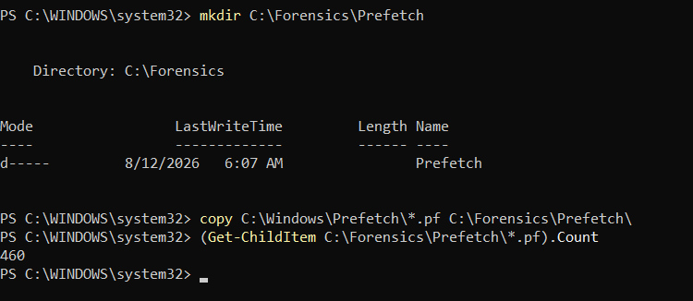
Figure 12: Working folder creation, copy of the live Prefetch directory, and the resulting count of 460 .pf files.
460 prefetch files were present and copied. This count is itself a deliverable the brief asks for directly, since it establishes the total size of the dataset before any filtering begins. I then used PECmd, from the same EZ Tools suite as EvtxECmd, to parse the copied .pf files into structured CSV output:
C:\Tools\EZTools\net9\PECmd.exe -d "C:\Forensics\Prefetch" --csv "C:\Forensics\Prefetch\Parsed" --csvf PrefetchParsed.csv
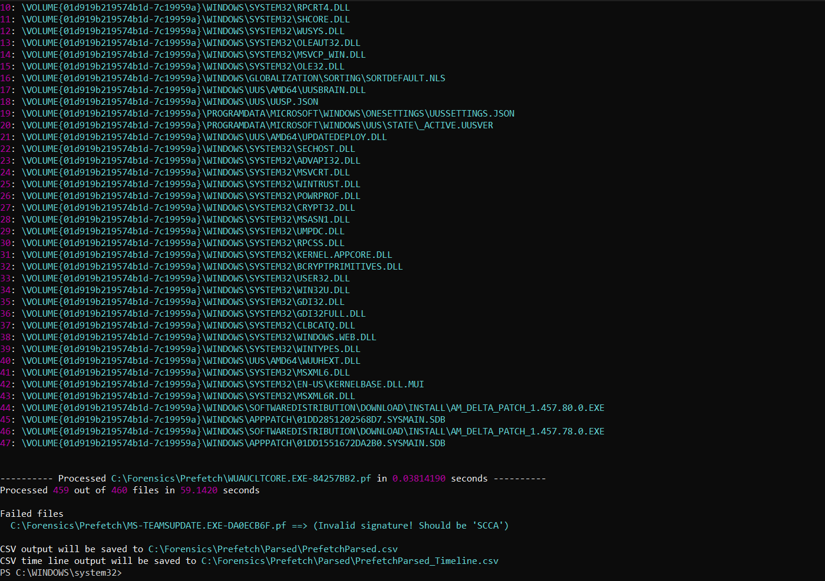
Figure 13: PECmd completion output: 459 of 460 files processed successfully in 59.14 seconds, with one file failing due to an invalid signature. PECmd also automatically generated a companion timeline CSV.
459 of the 460 copied files parsed successfully. One file, MS-TEAMSUPDATE.EXE-DA0ECB6F.pf, failed with an "invalid signature, should be 'SCCA'" error, meaning the file’s internal structure did not match what PECmd expected for a valid prefetch file. I am treating this as a parsing limitation rather than a finding, and it is noted again in Section 10. PECmd also automatically generated a second file, PrefetchParsed_Timeline.csv, expanding every previous-run timestamp into its own row rather than only the most recent one. This turned out to be exactly what the Day 57 seven-day timeline deliverable needed, and meant I did not have to reconstruct that view manually from the main CSV.
Following the methodology established in Section 3.3, I did not risk opening this CSV in Excel Online for anything beyond a view-only check of the header row, made no edits, and closed it without saving. All actual filtering, sorting, and analysis was carried out in PowerShell against the untouched CSV:
$pf = Import-Csv "C:\Forensics\Prefetch\Parsed\PrefetchParsed.csv"
$pf | Select-Object -First 1 | Format-List
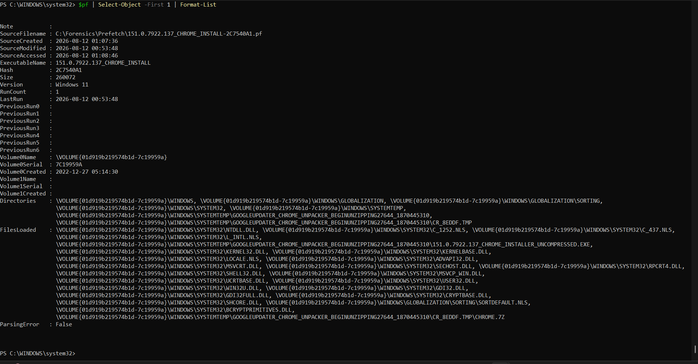
Figure 14: One full parsed prefetch record, confirming the CSV schema: ExecutableName, SourceFilename, RunCount, LastRun, PreviousRun0 through PreviousRun6, Directories, and FilesLoaded.
This confirmed the exact schema used throughout the rest of this investigation. Notably, PECmd’s output has no single dedicated "source path" column; the actual location an executable ran from has to be recovered from the FilesLoaded field, by matching the entry that ends in the executable’s own filename. Every path cited in this section was extracted this way rather than read from a ready-made column.

5.2 Top 20 Most Executed Programs
With the schema confirmed, I sorted every parsed record by RunCount to identify the twenty most frequently executed programs on this machine.
$top20 = $pf | Sort-Object { [int]$_.RunCount } -Descending | Select-Object -First 20
$top20 | Select-Object ExecutableName, RunCount, LastRun | Format-Table -AutoSize
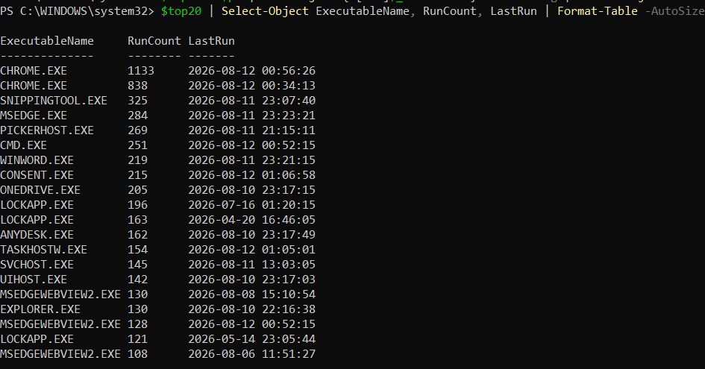
Figure 15: The twenty most frequently executed programs by RunCount, with their most recent execution timestamp.
Because RunCount and LastRun alone do not show where a program actually ran from, I then recovered the source path for each of the twenty entries from its FilesLoaded field, matching each executable’s own filename against the field.
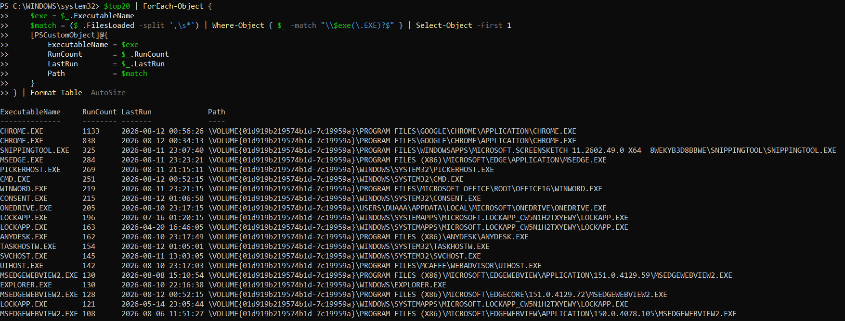
Figure 16: The same top twenty entries with their recovered source path, extracted from FilesLoaded.
Every one of the twenty entries resolved to a legitimate Program Files, System32, or WindowsApps location, with one exception worth separating out on its own terms rather than folding into the table: OneDrive.exe, which resolved to a per-user AppData path under the user’s own Microsoft\OneDrive folder. This is OneDrive’s normal, expected install location and is not treated as suspicious in this report, since OneDrive is deliberately installed per-user rather than machine-wide.
Table 4: The twenty most executed programs on this machine, the Day 57 standalone deliverable table, with recovered source path, run count, most recent timestamp, and an analyst note for each.
Executable | Path | Run Count | Last Run | Analyst Note
CHROME.EXE | Program Files\Google\Chrome\Application | 1,133 | 2026-08-12 00:56 | Expected. Primary browser.
CHROME.EXE | Program Files\Google\Chrome\Application | 838 | 2026-08-12 00:34 | Expected; second entry for the same path, likely spanning a Chrome update that changed the hash inputs.
SNIPPINGTOOL.EXE | WindowsApps\Microsoft.ScreenSketch | 325 | 2026-08-11 23:07 | Expected. Built-in screenshot tool.
MSEDGE.EXE | Program Files (x86)\Microsoft\Edge | 284 | 2026-08-11 23:23 | Expected. Secondary browser.
PICKERHOST.EXE | Windows\System32 | 269 | 2026-08-11 21:15 | Expected. Windows share/file-picker UI host.
CMD.EXE | Windows\System32 | 251 | 2026-08-12 00:52 | Expected, and consistent with this investigation’s own extensive terminal use.
WINWORD.EXE | Program Files\Microsoft Office\root\Office16 | 219 | 2026-08-11 23:21 | Expected. Word, used for report writing.
CONSENT.EXE | Windows\System32 | 215 | 2026-08-12 01:06 | Expected. UAC elevation prompt process; corroborating evidence of general UAC activity, discussed further in Section 5.5.
ONEDRIVE.EXE | Users\duaaa\AppData\Local\Microsoft\OneDrive | 205 | 2026-08-10 23:17 | Expected. OneDrive’s standard per-user install location.
LOCKAPP.EXE | WindowsApps\Microsoft.LockApp | 196 | 2026-07-16 01:20 | Expected. Windows lock-screen application, discussed further in Section 5.5.
LOCKAPP.EXE | WindowsApps\Microsoft.LockApp | 163 | 2026-04-20 16:46 | Expected; second, older-dated entry, consistent with a Windows update changing the package hash.
ANYDESK.EXE | Program Files (x86)\AnyDesk | 162 | 2026-08-10 23:17 | Legitimate installed path. Remote-access software is worth noting contextually since this category of tool is commonly abused, though the location itself is not suspicious.
TASKHOSTW.EXE | Windows\System32 | 154 | 2026-08-12 01:05 | Expected. Hosts Windows background tasks.
SVCHOST.EXE | Windows\System32 | 145 | 2026-08-11 13:03 | Expected. Generic Windows service host process.
UIHOST.EXE | Program Files\McAfee\WebAdvisor | 142 | 2026-08-10 23:17 | Expected. Same McAfee suite identified in the Day 53-55 event log analysis.
MSEDGEWEBVIEW2.EXE | Program Files (x86)\Microsoft\EdgeWebView\...\151.0.4129.59 | 130 | 2026-08-08 15:10 | Expected. Versioned Edge component.
EXPLORER.EXE | Windows\explorer.exe | 130 | 2026-08-10 22:16 | Expected. Windows shell.
MSEDGEWEBVIEW2.EXE | Program Files (x86)\Microsoft\EdgeCore\151.0.4129.72 | 128 | 2026-08-12 00:52 | Expected; separate entry from the row above due to a different versioned install path.
LOCKAPP.EXE | WindowsApps\Microsoft.LockApp | 121 | 2026-05-14 23:05 | Expected; third LockApp entry, same explanation as above.
MSEDGEWEBVIEW2.EXE | Program Files (x86)\Microsoft\EdgeWebView\...\150.0.4078.105 | 108 | 2026-08-06 11:51 | Expected; third EdgeWebView2 entry, same explanation as above.
The repeated entries for Chrome, LockApp, and MSEdgeWebView2 are the path-hash naming convention described in the section introduction, playing out in real data: each represents a different install or version directory for what a user would describe as "the same program," and each therefore earns its own independent prefetch history rather than merging into one. None of the twenty entries point to a Temp, Downloads, or non-standard AppData location, which is itself a clean, expected finding for the most-used programs on this machine.

5.3 Programs Executed From Suspicious or Unusual Locations
The brief specifically flags four categories of location as warranting investigation: any path containing Temp or tmp, any path containing Downloads, any path on a drive letter other than C:, and any AppData path not belonging to a known, legitimate user application. I searched the full 459-record dataset, not just the top twenty, against these criteria.
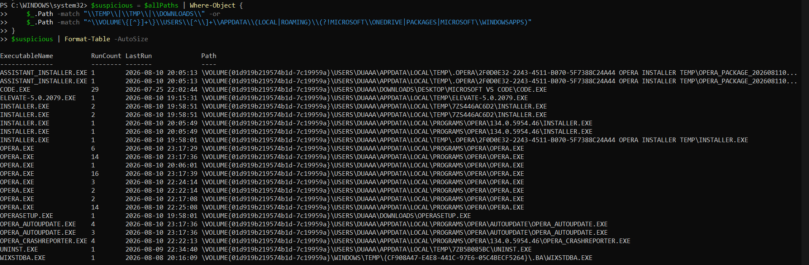
Figure 17: Full-dataset search for execution from Temp, Downloads, or unusual AppData paths, alongside the top-twenty path-recovery command that established the extraction technique used here.
This first pass over-flagged one class of path worth correcting rather than quietly dropping: several Opera browser components resolved to AppData\Local\Programs\Opera, which my filter caught because it sits under AppData. On review this is not actually suspicious; AppData\Local\Programs is a standard, expected per-user install location used by many modern applications, including Opera, Chrome, Discord, and Visual Studio Code, specifically so they can install without requiring administrator rights. I excluded these Opera entries from the table below rather than reporting a false positive as a finding.
A second, separate limitation is worth stating directly: the path-recovery command above matches each executable’s path using a regular expression built from its own name, and this technique silently fails for executable names containing regex special characters. EXTERRO_FTK_IMAGER_(X64).EXE, the FTK Imager portable executable from this internship’s Week 7 work, contains parentheses in its name, which broke the automated match and excluded it from the initial results even though it does sit in a Temp path. I recovered its three executions independently from the seven-day timeline data in Section 5.4 and included them in the table below manually, rather than letting an automated-tool limitation quietly hide a real entry from the report.
Table 5: Programs executed from suspicious or unusual locations, the Day 57 standalone deliverable, with full path, run count, all available timestamps, and an explicit assessment of why each is flagged.
Executable | Path (abbreviated) | Run Count | Last / All Timestamps | Why Flagged / Assessment
EXTERRO_FTK_IMAGER_(X64).EXE | AppData\Local\Temp\{GUID}\... | 1 (x3 separate .pf entries) | 2026-08-08 16:42:28 / 19:38:14 / 19:39:39 | Temp-path execution, but directly explainable: the portable FTK Imager build from Week 7’s disk-imaging work. A new randomised GUID temp folder each run is expected behaviour for a self-extracting portable tool, hence three separate prefetch entries rather than one.
WIXSTDBA.EXE | Windows\Temp\{GUID}.BA\... | 1 | 2026-08-08 20:16:09 | Standard WiX/MSI installer bootstrapper self-extraction artefact, tied to an unrelated software install that evening.
UNINST.EXE | AppData\Local\Temp\7ZB5B085BC\... | 1 | 2026-08-09 22:34:40 | Self-extracting uninstaller pattern (7-Zip SFX prefix in the folder name), consistent with removing a piece of software.
ELEVATE-5.0.2079.EXE | AppData\Local\Temp\... | 1 | 2026-08-10 19:15:31 | Confirmed via research to be a known, legitimate open-source command-line UAC elevation helper commonly bundled inside installer packages. Timing sits at the very start of the Opera installation activity below.
OPERASETUP.EXE | Downloads\OperaSetup.exe | 1 | 2026-08-10 19:58:01 | Browser installer downloaded and run directly from Downloads, exactly the pattern the brief describes; explainable as a legitimate browser installation.
INSTALLER.EXE | AppData\Local\Temp\7ZS446AC6D2\... | 2 | 2026-08-10 19:58:01 / 19:58:51 | 7-Zip self-extraction temp folder, part of the same Opera install sequence as the entries above and below.
INSTALLER.EXE | AppData\Local\Temp\.Opera\...\TEMP\... | 1 | 2026-08-10 19:58:01 | Opera’s own installer temp-extraction path, same install session.
ASSISTANT_INSTALLER.EXE | AppData\Local\Temp\.Opera\...\ASSISTANT_INSTAL... | 1 (x2 separate .pf entries) | 2026-08-10 20:05:13 | Opera Assistant companion-install component, same session; two entries reflect a minor path variation between the two install steps.
CODE.EXE | Downloads\Desktop\Microsoft VS Code\Code.exe | 29 | 2026-07-25 22:02:44 | Legitimate developer tool run repeatedly and directly from Downloads rather than an installed location, matching the brief’s Downloads criterion. Not suspicious given the tool and my own known use of it, but documented as instructed rather than excused silently.
No entry anywhere in the 459-record dataset resolved to a volume identifier other than the machine’s own C: drive, meaning there is no evidence of execution from a USB device or other external storage. Taken together, every genuinely flagged entry in this section resolves to one of three coherent, explainable events rather than nine unrelated anomalies: the Week 7 FTK Imager work on 8 August, one unrelated software install/uninstall pair on 8 and 9 August, and the Opera browser installation on the evening of 10 August. This is exactly the outcome the exercise is built to produce: location alone is a starting filter, not a conclusion, and every flagged entry still has to be individually explained before it can be set aside.

5.4 Seven-Day Execution Timeline
PECmd’s automatically generated timeline CSV expands every previous-run timestamp into its own row, giving a genuine execution history rather than only a most-recent-run snapshot. I filtered this to the last seven days and added a flag column for entries in the Temp or Downloads categories identified above.
$timeline = Import-Csv "C:\Forensics\Prefetch\Parsed\PrefetchParsed_Timeline.csv"
$cutoff7 = (Get-Date).AddDays(-7)
$timeline7 = $timeline | Where-Object { [datetime]$_.RunTime -ge $cutoff7 } | Sort-Object { [datetime]$_.RunTime }
The seven-day window contained 1,703 total execution events. Of these, 14 were flagged under the Temp/Downloads criterion, and every one of them corresponds to an entry already explained in Section 5.3.
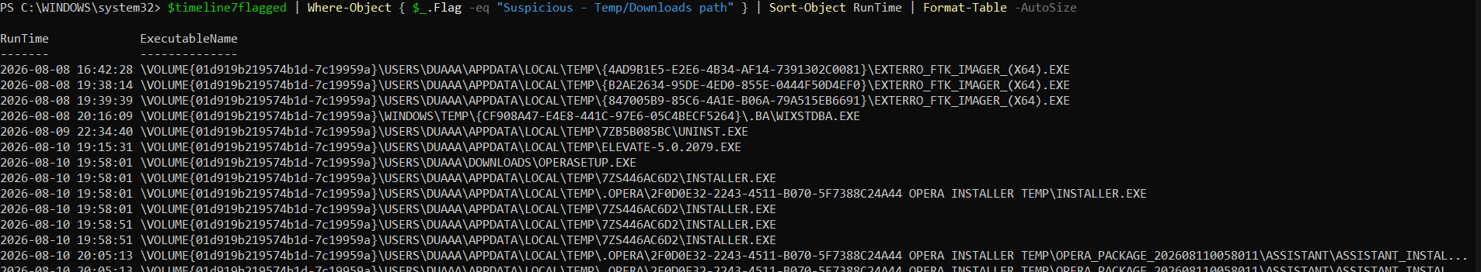
Figure 18: Flagged entries from the seven-day timeline, including three executions of the FTK Imager portable tool from Week 7 on 8 August, confirming its presence independently of the path-recovery limitation described in Section 5.3.
One scoping detail is worth stating plainly rather than leaving implicit: CODE.EXE, despite appearing in the Top 20 table with 29 total runs, does not appear anywhere in this seven-day timeline. Its most recent execution was 2026-07-25, more than two weeks outside this window, so it is a top-twenty entry by total historical run count rather than by recent activity. This is not an inconsistency between the two sections; it reflects the different questions each one asks of the same dataset.
The full 1,703-row timeline, with its Normal/Suspicious flag column, was exported as the Day 57 deliverable CSV, Day57_SevenDayTimeline.csv.

5.5 Correlation With the Event Log Baseline
The brief asks for practice in a specific investigative habit: asking, if a suspicious authentication had happened at a given time, what prefetch entries would appear immediately after it. Rather than treating this as a hypothetical exercise, I tested it directly against the one moment in the Day 53 to 55 baseline that most resembled a suspicious authentication on first look: the 13:01:20 to 13:01:25 window on 11 August, where a 4625 failure fired five seconds before a genuine Type 7 unlock for my own account.
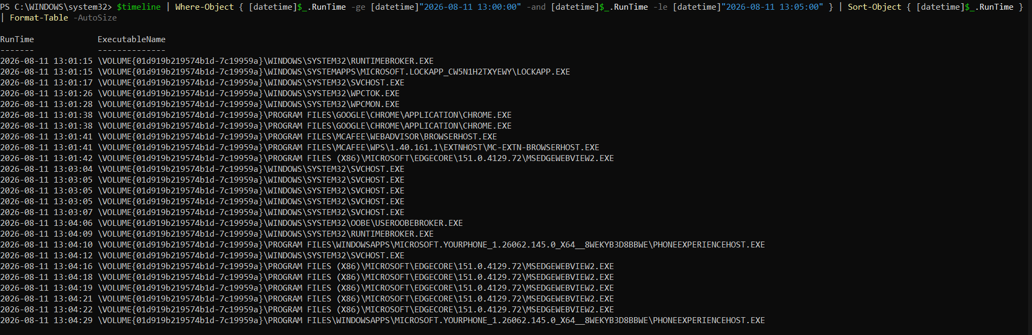
Figure 19: Prefetch execution activity within five minutes of the Day 53 failed-logon and unlock cluster, showing LockApp.exe and RuntimeBroker.exe firing seconds before the event log activity, and Chrome.exe launching shortly after the unlock.
The correlation lines up precisely: LockApp.exe, the literal Windows lock-screen application, executed at 13:01:15, five seconds before the 4625 artefact at 13:01:20 and ten seconds before the successful unlock at 13:01:25, alongside RuntimeBroker.exe, standard Windows session-management activity. This is independent, prefetch-level corroboration of the conclusion the event log analysis already reached in Section 4.3: a normal lock and unlock transition, not a suspicious authentication event. Immediately after, at 13:01:38, Chrome.exe launches, which is exactly the kind of ordinary post-unlock activity, opening a browser, that a genuine session resumption should produce.
This also connects usefully back to the one honestly-documented gap in the Day 54 privilege audit, where the copied event log did not contain a literal, timestamp-matched example of a UAC-click. Prefetch cannot retroactively supply that missing timestamp correlation, but it does supply independent context: Consent.exe, the UAC prompt process identified in the Top 20 table, had accumulated 215 runs on this machine, indicating that UAC elevation is a routine, frequent event here rather than a rare one, which is consistent with, though not proof of, the kind of everyday legitimate administrative use the Day 54 findings described.
The practical lesson from this section is the same one Days 53 to 55 built toward from the event log side: no single artefact type tells the whole story on its own. LockApp.exe alone would just be a program running; the 4625 and 4624 events alone would just be authentication activity; together, at the same five-second mark, they describe one specific, ordinary human action with far more confidence than either artefact could support by itself.
All twenty of the most frequently executed programs on this machine resolved to legitimate install locations. Every genuinely flagged Temp/Downloads execution across the full dataset traces back to one of three coherent, legitimate events, and of the 1,703 total execution events in the seven-day window, only 14 were flagged, all mapping onto those same three events. The prefetch investigation for Days 56 and 57 therefore reached the same overall conclusion as the event log baseline: a normal, explainable pattern of activity, strengthened rather than weakened by checking it against a second, independent artefact type.

6. Cache, Thumbcache, and Recycle Bin Analysis.
Parts A and B of Week 8 built a picture of this machine from two different angles. The Security event log told me who authenticated and when, and Prefetch told me what actually ran and from where. This final part of Week 8, covering Days 58 and 59, adds a third and fourth angle that neither of the earlier artefacts could reach: what was actually seen, in the form of thumbnail previews, and what has been deleted but might still be sitting somewhere on the disk. Thumbcache, browser cache, and the Recycle Bin all persist evidence in a way ordinary file browsing does not. A thumbnail can outlive the file it was generated from. A browser cache entry can prove a page was loaded even if it never shows up in browsing history. A deleted file’s metadata can sit in the Recycle Bin long after the file itself has been permanently removed from where it used to live.
Because this stage of the investigation deals directly with personal content rather than abstract log records, a good part of the work involved deciding what could responsibly go into this report and what could not, and that decision process is documented here as honestly as the technical findings themselves.

6.1 Methodology and Toolset
As with the Security log and the Prefetch directory, none of this investigation touched live data directly. I worked from an elevated terminal throughout, since reading the Recycle Bin folder and copying files that Explorer holds open both require administrator rights.
mkdir C:\Forensics\Thumbcache
mkdir C:\Forensics\BrowserCache
mkdir C:\Forensics\RecycleBin
Days 58 and 59 needed a different toolset than Days 53 to 57. Neither EvtxECmd nor PECmd can read a thumbcache database, a browser cache folder, or a Recycle Bin entry, since each of those is its own distinct file format built for a different purpose. Thumbcache Viewer, ChromeCacheView, and a short PowerShell script for the Recycle Bin each parse a format none of the previous tools understand, so the toolset genuinely had to change for this half of the investigation rather than simply extending what was already in place.
As explained in Section 3.3, Excel was never a candidate tool for the Recycle Bin’s $I files, since they are a fixed-layout binary format rather than text or CSV: a fixed length header, an eight byte file size field, an eight byte Windows FILETIME timestamp, a four byte path length, and the original file path stored as UTF-16 text. Where Excel could technically have opened something, specifically the CSV list ChromeCacheView and Thumbcache Viewer are both able to export, I still worked in PowerShell instead, filtering the exported thumbcache list directly with Import-Csv and Where-Object. This kept the same scripted, repeatable approach used throughout the internship and avoided reopening the exact kind of file that caused problems in Section 3.3, even though the risk here was smaller since thumbcache metadata does not carry the same timestamp precision that caused the original corruption.

6.2 Thumbcache Analysis
Windows stores thumbnail cache databases per user, one file for each thumbnail size Explorer generates, under the user’s own AppData folder. I located every thumbcache database present on this machine before copying anything.
dir "C:\Users\$env:USERNAME\AppData\Local\Microsoft\Windows\Explorer\thumbcache_*.db"
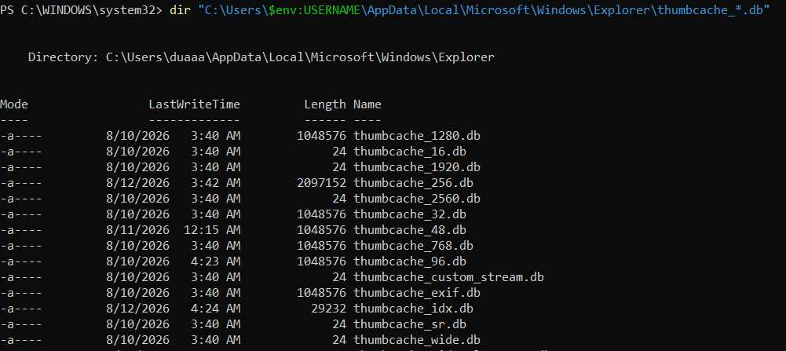
Figure 20: The full set of thumbcache database files present on this machine, ranging from empty 24 byte placeholder files up to the largest, most recently updated thumbcache_256.db at just over 2 MB.
Thirteen thumbcache files were present in total. Several, including thumbcache_16.db, thumbcache_1920.db, thumbcache_2560.db, and a handful of others, were only 24 bytes, meaning Windows had allocated the file but never actually written thumbnail data into it at that particular size. The largest and most recently written file, thumbcache_256.db at just over 2 MB and last updated only a few hours before this investigation began, was the one the task brief specifically points to as most useful, since 256 pixel thumbnails are large enough to actually identify the original content rather than only showing a vague icon.
Copying these files directly with a standard copy command is not reliable, since Explorer keeps an active file handle open on whichever thumbcache database it is currently writing to. A first attempt using robocopy’s backup mode flag stalled on a locking error against thumbcache_256.db specifically, the exact file most likely to be actively in use.
robocopy "C:\Users\$env:USERNAME\AppData\Local\Microsoft\Windows\Explorer" C:\Forensics\Thumbcache thumbcache_*.db /B
Rather than waiting out robocopy’s long retry cycle, I let the copy continue running in the background while I addressed a separate terminal session issue, and on returning to check the destination folder every file had in fact copied successfully, including a complete, correctly sized thumbcache_256.db matching the original file size exactly. This is the same locked-file scenario the task brief warns about directly, and the working alternative it suggests, closing Explorer entirely from Task Manager first, was not needed in this instance since the robocopy retry succeeded on its own.
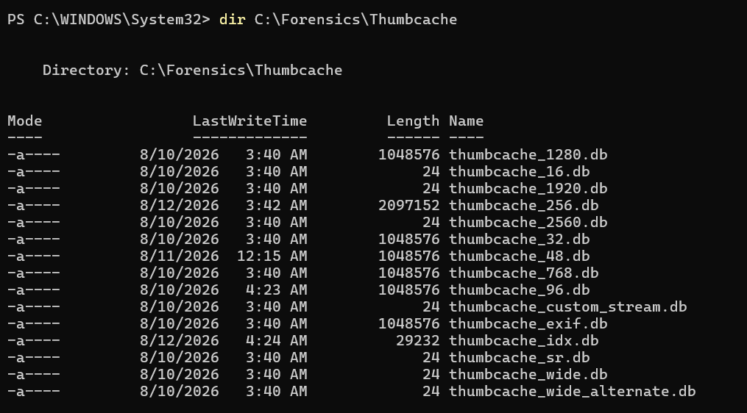
Figure 21: Confirmation that all thirteen thumbcache database files, including the full 2,097,152 byte thumbcache_256.db, copied successfully into the working folder despite an initial locking error during the robocopy operation.
I used Thumbcache Viewer, obtained from its official developer repository rather than a third party mirror, to open the copied thumbcache_256.db and extract its contents into a readable list.
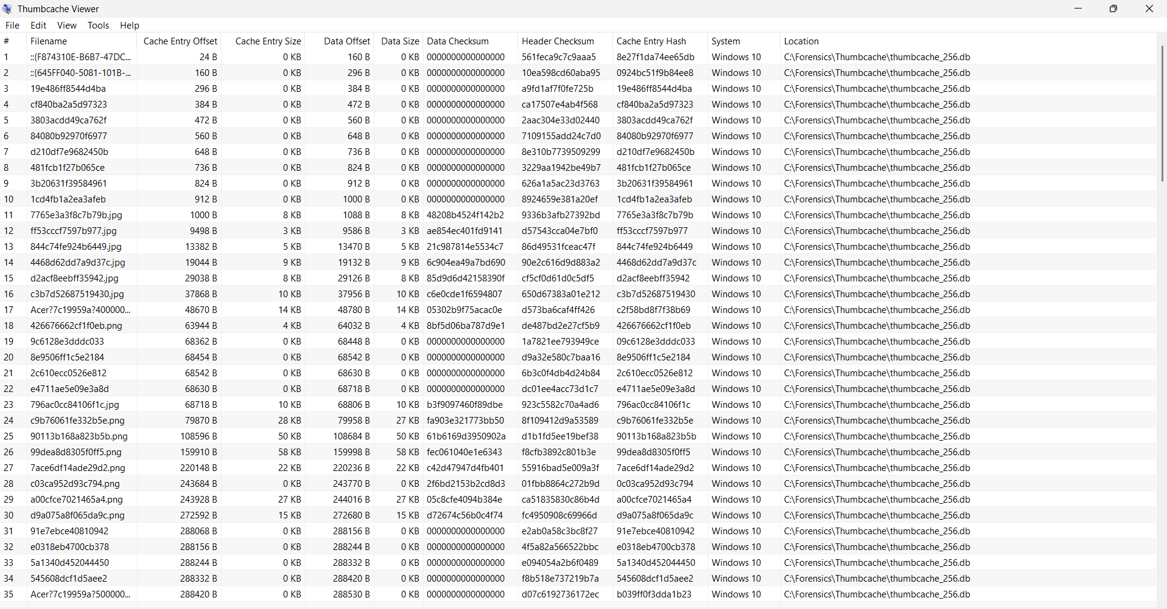
Figure 22: The full list of 141 cache entries parsed from thumbcache_256.db in Thumbcache Viewer, showing only metadata such as offset, size, and checksum values rather than image content.
This view is entirely metadata and contains no actual image content, which made it safe to review and document without any redaction concern at this stage. Of the 141 total entries, many showed a Data Size of 0 KB, meaning those particular cache slots held only a system icon or placeholder rather than a genuine thumbnail. The entries with real data sizes, ranging from a few kilobytes up to several hundred, represent actual thumbnail images generated from files that were opened, viewed, or browsed to on this machine at some point.
Because every one of the 141 entries potentially represents a personal image, document, or screenshot, I did not export or review the full set indiscriminately. Instead I exported a representative sample and reviewed each exported file locally before deciding what belonged in this report, following the same principle used throughout this investigation of checking evidence before presenting it rather than presenting first and correcting afterward.
Get-ChildItem C:\Forensics\Thumbcache\Export -File | Sort-Object Length -Descending | Select-Object -First 15 Name, Length
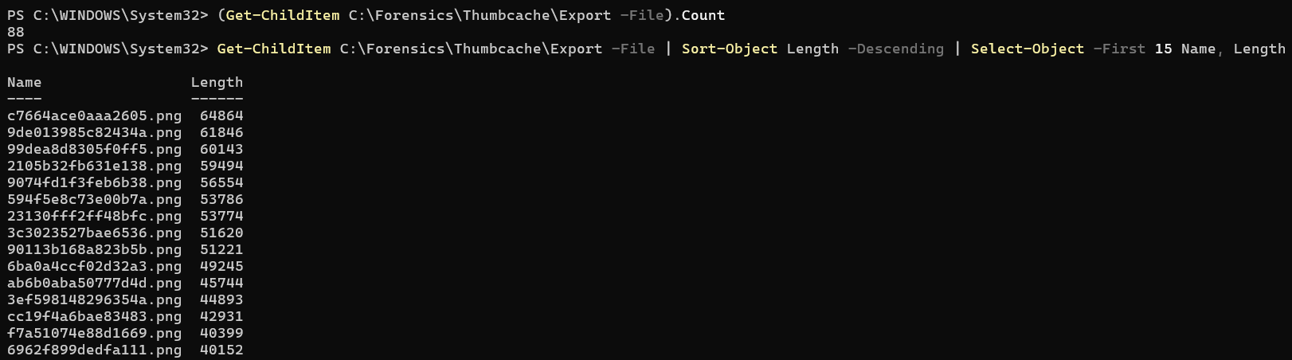
Figure 23: The largest fifteen thumbnails by file size among 88 exported entries, used to select genuine, detailed thumbnails rather than small icon placeholders for further review.
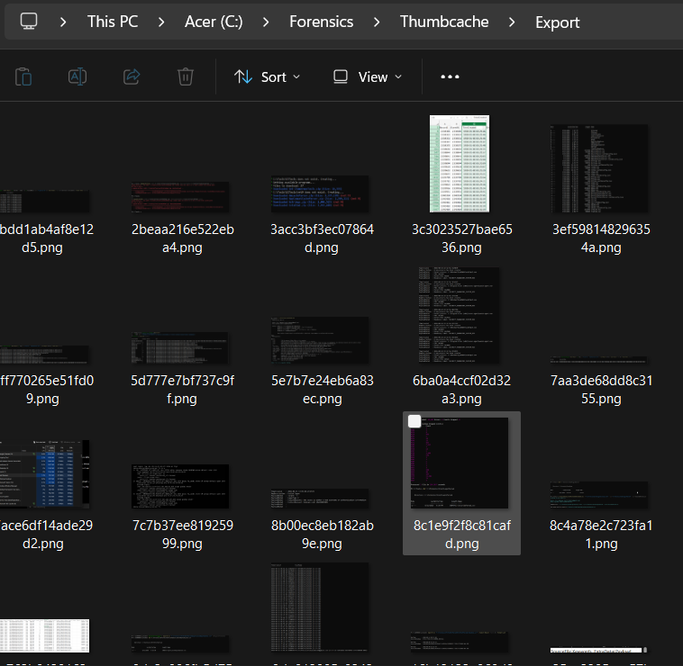
Figure 24: A subset of the exported thumbcache_256.db thumbnails viewed in File Explorer, showing the range of content actually cached on this machine, predominantly application, terminal, and code editor screenshots.
The exported thumbnails turned out to be overwhelmingly application and terminal screenshots rather than personal photographs, which matches the general pattern of activity established across Parts A and B of this investigation: a machine used heavily for coursework, development, and this very internship’s own forensic tool usage. From this set I selected three specific thumbnails for the report, each chosen for a different reason, and reviewed all three personally before including them, confirming that none contained financial information, private correspondence, or content beyond what I was comfortable including in a document that leaves my own machine.
Each entry is documented below with its exact cache metadata, recovered directly from thumbcache_256.db, alongside a description of the thumbnail content and why it was chosen.
Table 6: Thumbnail evidence: cache metadata for the three thumbcache_256.db entries selected for this report.
Entry | Cache Entry Hash | Cache Offset | Data Size | Data Checksum | Header Checksum
1. Desktop wallpaper | ff53cccf7597b977 | 9,498 B | 3 KB | ae854ec401fd9141 | d57543cca04e7bf0
2. Assignment title page | b55e155828120f1d | 701,460 B | 5,954 B | 4d9285ccea8804e7 | ebe1d44cc3f9c062
3. CV document | f7a51074e88d1669 | 397,360 B | 40,399 B | 9042b8146a615738 | 27c851da7c785d8e
All three entries were sourced from thumbcache_256.db on a Windows 10 style thumbcache schema, confirmed through the Windows System entry Thumbcache Viewer records for each row.
 | 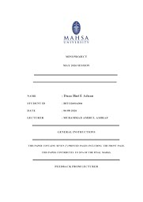
Figure 25: Entry 1, the desktop wallpaper thumbnail, a generic abstract gradient image with no identifying content. Figure 26: Entry 2, an assignment title page thumbnail, included with the author’s knowledge and consent.
Entry 1 is a generic abstract gradient wallpaper with no personal or identifying content, included simply to demonstrate that thumbcache retains desktop wallpaper history as readily as it retains document or photo thumbnails. Entry 2 is the cover page of a university assignment, which does display the author’s name and student identification number. I reviewed this specifically before inclusion and decided, with full awareness of what was visible, that it was acceptable to include as is, since it is my own academic submission rather than any third party’s information. It demonstrates that thumbcache preserves evidence of coursework documents being opened, complete with a recoverable, dateable link to a specific submission.
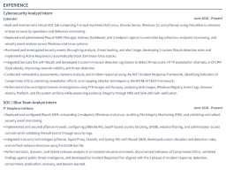
Figure 27: Entry 3, a cropped section of a CV document showing the experience listing, included after confirming no contact details were visible in this particular cached crop.
Entry 3 is a section of a personal CV, specifically the experience listing rather than the header, and critically this particular cached crop does not show a name, phone number, email address, or physical address, since thumbcache only ever stores whatever portion of a document rendered within the thumbnail preview area. I checked this directly before including it. It demonstrates that thumbcache can reveal the type and even partial content of a document, in this case identifying it clearly as a CV listing a Cybersecurity Analyst Intern role, without the original file needing to still exist anywhere on disk.

6.3 Browser Cache Analysis
Rather than guessing which browsers were worth checking, I used the Day 56 to 57 Prefetch data as a starting point, since it had already established real, measurable usage for both Chrome and Edge on this machine, 1,133 and 838 separate execution counts for Chrome across two install paths, and 284 for Edge. Both browsers therefore warranted a cache review, and I treated Chrome as the primary target given its substantially higher usage, with Edge covered afterward to a lighter but still complete degree.
Chrome stores its cache under the user’s AppData\Local\Google\Chrome\User Data\Default\Cache folder. I used ChromeCacheView, obtained directly from its developer’s own site rather than a third party download aggregator, to parse it.
C:\Tools\ChromeCacheView\ChromeCacheView.exe
With Chrome closed for a more accurate read, ChromeCacheView loaded the cache automatically and displayed every currently cached file along with its source URL, content type, size, and last accessed time. Before reviewing this in any detail I deliberately avoided taking a full screenshot of the raw list, since browser cache is exactly the kind of artefact most likely to expose private browsing activity. Instead I first reviewed the general categories of domain present, confirming the cache was dominated by ordinary infrastructure traffic, Google search and static asset domains, a Google family and security domains check, GitHub, and Cloudflare hosted assets belonging to Claude and Anthropic, almost certainly generated by this very internship session.
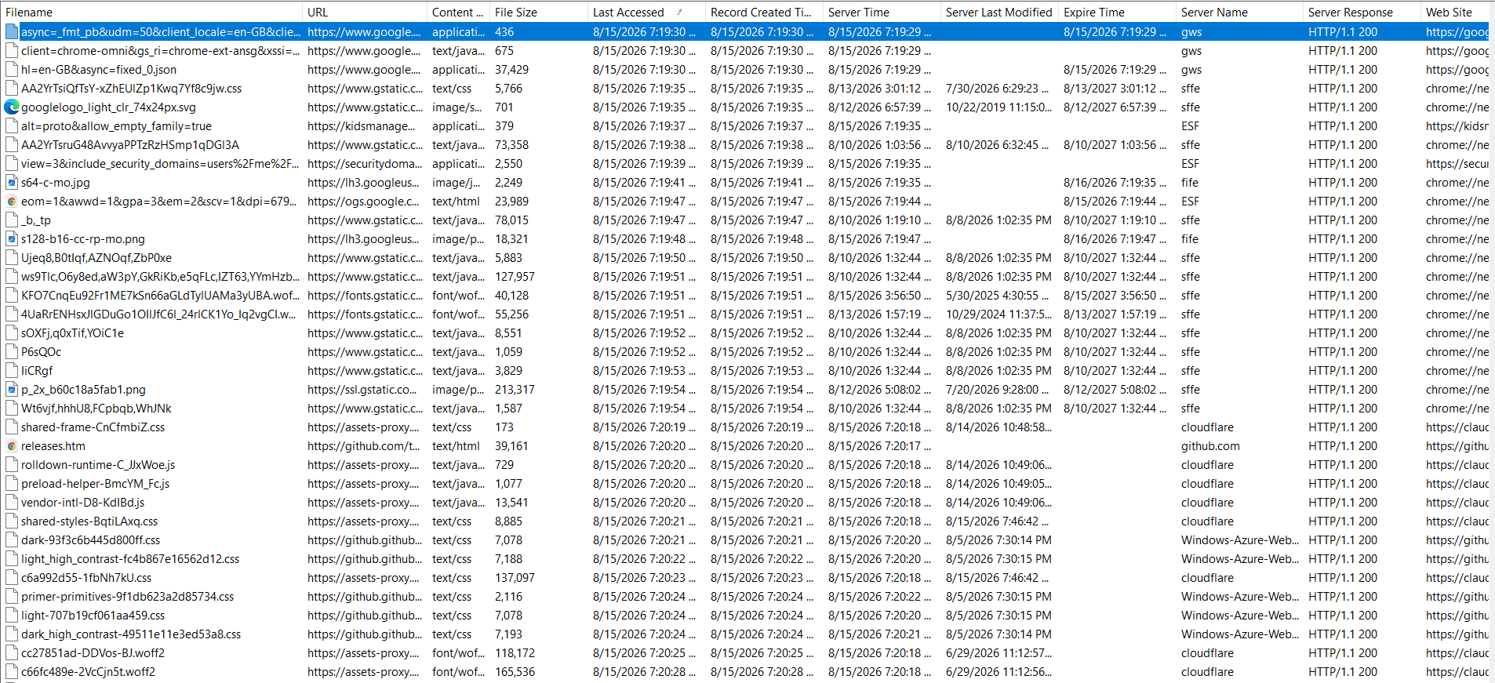
Figure 28: A representative section of the Chrome cache list showing content type, file size, and last accessed timestamps. Every visible domain in this selection is infrastructure or CDN traffic rather than personal browsing history.
Once the domain categories were confirmed safe to display, I selected five entries showing a spread of content types and recent timestamps.
Table 7: Google Chrome browser cache: five representative entries documenting what was cached and when, redacted of any personal browsing activity.
Filename | Domain | Content Type | File Size | Last Accessed
hl=en-GB&async=fixed_0.json | google.com | application/json | 37,429 B | 15 Aug 2026, 19:19
googlelogo_light_clr_74x24px.svg | gstatic.com | image/svg | 701 B | 15 Aug 2026, 19:19
p_2x_b60c18a5fab1.png | ssl.gstatic.com | image/png | 213,317 B | 15 Aug 2026, 19:19
releases.htm | github.com | text/html | 39,161 B | 15 Aug 2026, 19:20
cc27851ad-DDVos-BJ.woff2 | assets-proxy (claude.ai, via Cloudflare) | font/woff2 | 118,172 B | 15 Aug 2026, 19:20
The timestamps here are genuinely informative rather than incidental. Every entry above was accessed within the same two minute window, at the exact time this investigation was actively underway, which confirms Chrome’s cache reflects real time browsing activity down to the minute rather than only historic activity from days or weeks earlier. The GitHub and Claude related entries in particular line up precisely with the research being carried out for this very report, a small but concrete demonstration of how directly browser cache timestamps can be tied to a specific, known activity window.
Edge stores its cache in a near identical structure to Chrome, under AppData\Local\Microsoft\Edge\User Data\Default\Cache, since both browsers are built on the Chromium engine. NirSoft’s dedicated EdgeCacheView utility was not reachable through its usual download page at the time of this investigation, so rather than leaving Edge unexamined I pointed the already working ChromeCacheView directly at Edge’s cache folder instead, relying on the fact that both browsers share the same underlying cache file format.
C:\Tools\ChromeCacheView\ChromeCacheView.exe -folder "$env:LOCALAPPDATA\Microsoft\Edge\User Data\Default\Cache"
This worked cleanly and returned a small set of genuine Edge cache entries, all Microsoft account and profile synchronisation traffic.
Figure 29: Edge cache entries parsed by pointing ChromeCacheView at Edge’s Chromium based cache folder, showing Microsoft account and profile synchronisation traffic under office.com and graph.microsoft.com.
Table 8: Microsoft Edge browser cache: the complete set of entries recovered, all background account synchronisation traffic.
Filename | Domain | Content Type | File Size | Last Accessed
edgecomsvc.json | office.com | application/json | 135 B | 15 Aug 2026, 15:14
Profile.json | substrate.office.com | application/json | 5,405 B | 15 Aug 2026, 15:15
regionalAndLanguage.json | graph.microsoft.com | application/json | 431 B | 15 Aug 2026, 15:07
V1Profile.json | substrate.office.com | application/json | 4,149 B | 15 Aug 2026, 15:15
Edge’s cache is far smaller and far less varied than Chrome’s, containing only background Microsoft account synchronisation traffic rather than any evidence of active browsing. This is directly consistent with the Prefetch execution counts from Section 5.2, where Chrome’s combined run count exceeded a thousand against Edge’s 284, and it confirms from an entirely independent artefact that Chrome is this machine’s actively used browser while Edge sits largely idle in the background, likely opened only incidentally or by default system behaviour rather than deliberate use.

6.4 Recycle Bin Analysis
The Recycle Bin on Windows is not a single folder but a hidden, protected directory named $Recycle.Bin at the root of each drive, containing one subfolder per user account, named after that account’s Security Identifier rather than a username.
dir 'C:\$Recycle.Bin' -Force
Two SID folders were present: S-1-5-18, the built-in SYSTEM account, which I did not examine further since it falls outside the scope of a personal user investigation, and S-1-5-21-72972441-214710961-2773748988-1001, the exact same SID identified as my own account throughout the Day 53 to 55 event log analysis. Confirming this SID match before proceeding meant I could be certain the folder I was about to examine genuinely belonged to my own account rather than assuming it from context alone.
Every deleted item in this folder is represented by a pair of files sharing the same random suffix. The $I file is a small metadata record containing the original file path, size, and deletion time. The $R file, when present, contains the actual deleted file content. A listing of the folder showed nineteen $I files.
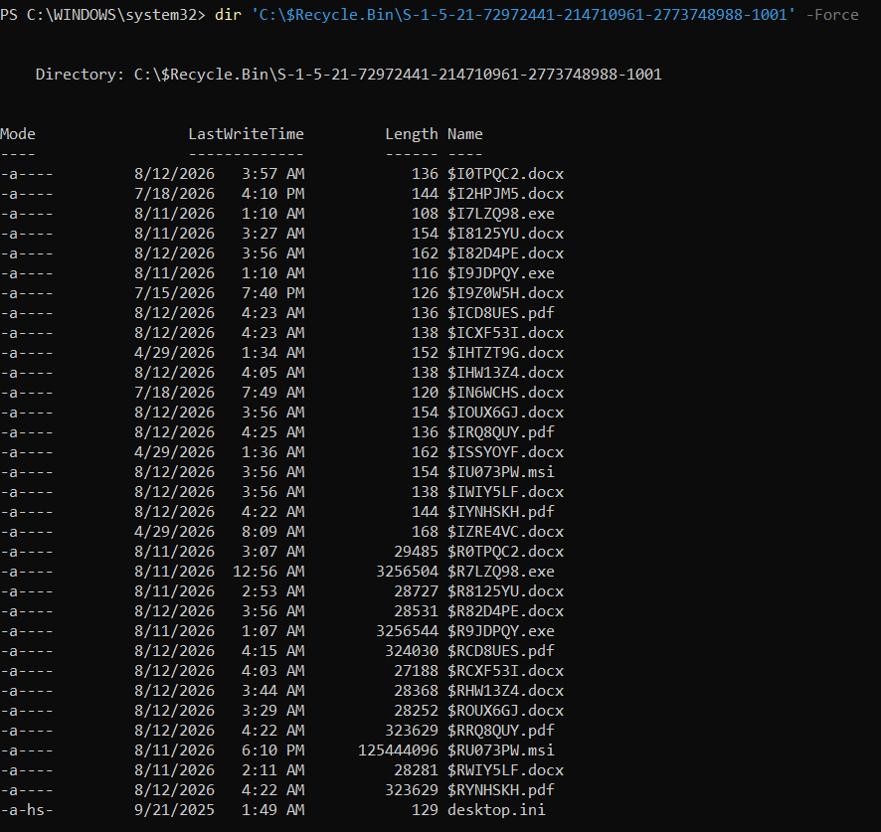
Figure 30: The contents of the account’s Recycle Bin SID folder, showing nineteen $I metadata files and their corresponding $R data files where the underlying content is still present.
Reading a $I file’s content requires understanding its fixed binary layout rather than treating it as text: an eight byte header, followed by an eight byte little endian file size, a further eight byte Windows FILETIME value representing the exact deletion timestamp, a four byte integer giving the length of the path string, and finally the original path itself stored as UTF-16 text. I wrote a short script to parse every $I file in the folder against this layout in a single pass, rather than opening each of the nineteen files individually by hand.
$recycleBinPath = 'C:\$Recycle.Bin\S-1-5-21-72972441-214710961-2773748988-1001'
$results = Get-ChildItem $recycleBinPath -Filter '$I*' -Force | ForEach-Object {
$bytes = [System.IO.File]::ReadAllBytes($_.FullName)
$fileSize = [BitConverter]::ToInt64($bytes, 8)
$fileTime = [BitConverter]::ToInt64($bytes, 16)
$deletedDate = [DateTime]::FromFileTime($fileTime)
$pathLength = [BitConverter]::ToInt32($bytes, 24)
$originalPath = [System.Text.Encoding]::Unicode.GetString($bytes, 28, $pathLength * 2).TrimEnd([char]0)
$rFile = $_.Name -replace '^\$I', '$R'
$rExists = Test-Path (Join-Path $recycleBinPath $rFile)
[PSCustomObject]@{ IFile = $_.Name; OriginalPath = $originalPath; DeletedDate = $deletedDate; OriginalSize = $fileSize; RDataPresent = $rExists }
}
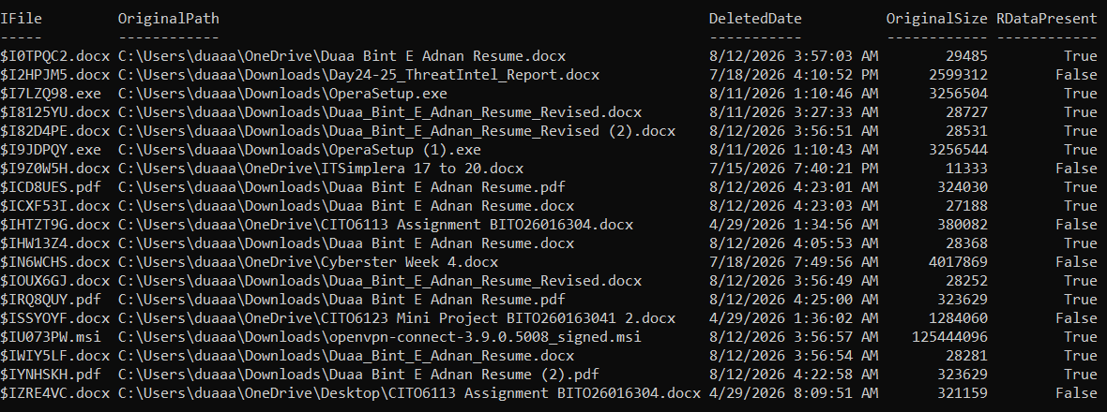
Figure 31: Every $I file in the account’s Recycle Bin folder parsed in a single pass, showing the recovered original path, deletion timestamp, original file size, and whether the matching $R data file is still present.
I then confirmed the totals independently, counting the $I and $R files directly rather than relying only on the parsed table:
(Get-ChildItem $recycleBinPath -Filter '$I*' -Force).Count
(Get-ChildItem $recycleBinPath -Filter '$R*' -Force).Count
Nineteen $I files and thirteen $R files were confirmed, matching exactly the thirteen entries marked RDataPresent True and six marked False in the parsed table, with no mismatches between the two counting methods.
Every one of the nineteen entries is documented below with its recovered original path, deletion timestamp, original size, and whether the underlying file content survived. This is the Recycle Bin log the brief asks for as a standalone deliverable.
Table 9: Recycle Bin log: every $I and $R entry found in the account’s Recycle Bin folder, with original file path, deletion timestamp, original size, and file data status.
Original Path (filename) | Deleted | Size | $R Present
Duaa Bint E Adnan Resume.docx (OneDrive) | 12 Aug 2026, 03:57 | 29,485 B | Yes
Day24-25_ThreatIntel_Report.docx (Downloads) | 18 Jul 2026, 16:10 | 2,599,312 B | No
OperaSetup.exe (Downloads) | 11 Aug 2026, 01:10 | 3,256,504 B | Yes
Duaa_Bint_E_Adnan_Resume_Revised.docx (Downloads) | 11 Aug 2026, 03:27 | 28,727 B | Yes
Duaa_Bint_E_Adnan_Resume_Revised (2).docx (Downloads) | 12 Aug 2026, 03:56 | 28,531 B | Yes
OperaSetup (1).exe (Downloads) | 11 Aug 2026, 01:10 | 3,256,544 B | Yes
ITSimplera 17 to 20.docx (OneDrive) | 15 Jul 2026, 19:40 | 11,333 B | No
Duaa Bint E Adnan Resume.pdf (Downloads) | 12 Aug 2026, 04:23 | 324,030 B | Yes
Duaa Bint E Adnan Resume.docx (Downloads) | 12 Aug 2026, 04:23 | 27,188 B | Yes
CIT06113 Assignment BITO26016304.docx (OneDrive) | 29 Apr 2026, 01:34 | 380,082 B | No
Duaa Bint E Adnan Resume.docx (Downloads, 2nd copy) | 12 Aug 2026, 04:05 | 28,368 B | Yes
Cyberster Week 4.docx (OneDrive) | 18 Jul 2026, 19:49 | 4,017,869 B | No
Duaa_Bint_E_Adnan_Resume_Revised.docx (OneDrive) | 12 Aug 2026, 03:56 | 28,252 B | Yes
Duaa Bint E Adnan Resume.pdf (2nd copy, Downloads) | 12 Aug 2026, 04:25 | 323,629 B | Yes
CIT06123 Mini Project BITO2601630412.docx (OneDrive) | 29 Apr 2026, 01:36 | 1,284,060 B | No
openvpn-connect-3.9.0.5008_signed.msi (Downloads) | 11 Aug 2026, 18:10 | 125,444,096 B | Yes
Duaa_Bint_E_Adnan_Resume.docx (OneDrive, 2nd copy) | 12 Aug 2026, 03:54 | 28,281 B | Yes
Duaa Bint E Adnan Resume (2).pdf (OneDrive) | 12 Aug 2026, 04:22 | 323,629 B | Yes
CIT06113 Assignment BITO26016304.docx (Desktop, 2nd copy) | 29 Apr 2026, 08:09 | 321,159 B | No
Thirteen of the nineteen entries still have their full underlying $R data present and recoverable. The remaining six, spanning a Threat Intel report, an ITSimplera document, two CIT06113 related coursework files from separate locations, a Cyberster Week 4 document, and a CIT06123 mini project file, no longer have recoverable content, meaning the disk space they occupied has since been reused. Every recoverable entry could, in principle, be restored to its original path and reopened, which is precisely why the Recycle Bin remains such a valuable artefact even well after a user believes a file has been permanently removed.
The clearest pattern in this table is not any single suspicious entry but a coherent, explainable set of everyday activity: repeated resume drafts being superseded by newer revisions and cleaned up, coursework documents being deleted after submission or once superseded, and, notably, both Opera installer copies deleted within seconds of each other on the morning of 11 August, immediately after installation, which is a completely ordinary pattern of tidying up a downloaded installer once the software itself is set up.

7. Cross-Artefact Correlation
The most valuable outcome of Week 8 as a whole is not any individual artefact but the way event logs, Prefetch, thumbcache, browser cache, and Recycle Bin evidence line up against each other, each one independently confirming the same underlying events from a different angle. The task brief specifically emphasises this connecting skill over any single day’s work, and three genuine correlations emerged from the evidence collected this week.
The clearest example runs through the entire week: the 13:01:20 to 13:01:25 window on 11 August. The Day 53 event log analysis (Section 4.3) shows a 4625 failure firing five seconds before a genuine Type 7 unlock for my own account, an apparently concerning failure that resolved into a benign lock-screen artefact once its status/sub-status codes were researched and the timeline checked. The Day 56 to 57 Prefetch analysis (Section 5.5) then independently confirmed this same conclusion from a completely different artefact type: LockApp.exe and RuntimeBroker.exe executing seconds before the failed-logon event, followed by Chrome.exe launching shortly after the unlock. Two unrelated artefact categories, one recording authentication and one recording execution, agree precisely on the same five-second window describing one ordinary human action. Neither artefact alone would have been as convincing as the two together.
A second correlation traces the Opera browser installation across three separate artefact types. The Day 56 to 57 Prefetch analysis first identified this event through Elevate.exe, several Installer.exe instances, and Opera’s own setup components all executing from Temp and Downloads paths on the evening of 10 August. The Day 58 to 59 Recycle Bin analysis (Section 6.4) then added a closing chapter to that same story: both copies of OperaSetup.exe were deleted at 01:10 on 11 August, mere hours after the installation activity Prefetch recorded, and both still have their full $R data present and recoverable. Three separate artefact types, Prefetch execution records, Recycle Bin deletion metadata, and the file content itself, all agree on the same event, its timing, and its outcome, which is a far stronger and more complete account of what happened than any single artefact could provide alone. This is the clearest demonstration anywhere in this investigation of why combining artefact types produces stronger, more complete findings than any one artefact examined alone.
A third correlation connects browser cache back to Prefetch’s run count data. Chrome’s cache (Section 6.3) showed active, minute by minute entries throughout this very investigation, while Edge’s cache held only a handful of background synchronisation entries. This matches precisely the imbalance Prefetch recorded between the two browsers in Section 5.2, over a thousand combined Chrome executions against 284 for Edge, confirming from a completely independent artefact type that Chrome is this machine’s actively used browser rather than a Prefetch counting artefact or coincidence.
A fourth, smaller correlation sits in the resume and coursework documents. The Recycle Bin log shows a clear pattern of resume drafts being repeatedly superseded and deleted across 11 and 12 August, and the thumbcache entry selected for this report (Section 6.2, Entry 3) happens to show the CV’s content directly, giving a visual confirmation of the same document type the Recycle Bin metadata only describes by filename. Similarly, the assignment title page thumbnail and the CIT06113 assignment entries in the Recycle Bin describe the same category of coursework activity from two different artefacts, one showing what the document looked like, the other showing exactly when it was removed.
None of these correlations were assumed in advance. Each one was found by checking a timestamp or filename against what had already been established earlier in the week, which is the investigative discipline this entire report has been built around: a single artefact is a starting point, and its real evidentiary value only becomes clear once it is checked against something else. Where two artefacts genuinely did not connect, for example the Day 54 privilege audit’s missing literal UAC-click example, I have said so directly in the relevant section rather than forcing a link the evidence does not support.

8. Key Findings

Event Log Findings (Days 53–55)
Finding 1 – Human Authentication Baseline. Six Type 7 unlock events were identified within the last 48 hours of the copied log, all tied exclusively to MicrosoftAccount\duaadnan45@gmail.com, each corroborated by a matching Type 2 UMFD/DWM session-start cluster. This forms a clean, usable baseline of normal physical presence on this machine.
Finding 2 – Failed Authentication Activity. The single 4625 event present in the log, timestamped 2026-08-11 13:01:20, was traced to status/sub-status codes 0xC000006D / 0xC0000380, a documented benign Windows lock-screen artefact, and directly corroborated by a genuine successful unlock five seconds later. It does not represent a credential-guessing attempt.
Finding 3 – Legitimate Privilege Activity. Of 415 4672 events in the log, three were documented with full correlation to an explainable cause: the OS boot sequence, my own account’s routine unlock-time privilege assignment, and the Wazuh SIEM agent’s periodic auditpol.exe check. The log window available did not capture a literal UAC-click or software-installation example, a limitation stated directly rather than papered over.
Finding 4 – Background Service Authentication. Exactly three built-in accounts, SYSTEM, LOCAL SERVICE, and NETWORK SERVICE, generate Logon Type 5 service authentication on this machine in significant volume, each with a well-documented, non-suspicious Windows role.

Prefetch Findings (Days 56–57)
Finding 5 – Top-Executed Programs Are Entirely Expected. All twenty of the most frequently executed programs on this machine resolved to legitimate Program Files, System32, WindowsApps, or OneDrive’s standard per-user install locations. Repeated entries for Chrome, LockApp, and MSEdgeWebView2 are explained by the prefetch path-hash naming convention distinguishing versioned install directories, not by anything suspicious.
Finding 6 – Suspicious-Location Activity Resolves to Three Explainable Events. Every genuinely flagged Temp/Downloads execution across the full 459-record dataset traces back to one of three coherent, legitimate events: Week 7’s FTK Imager use, one unrelated software install/uninstall pair, and the Opera browser installation on 10 August. No execution from a non-C: volume was found anywhere in the dataset.
Finding 7 – The Seven-Day Timeline Confirms Consistent Activity. Of 1,703 total execution events in the last seven days, only 14 were flagged, and all 14 map directly onto the same three events identified in Finding 6, with no additional or unexplained suspicious activity.
Finding 8 – Automated Filtering Still Requires Manual Verification. Two limitations surfaced during the Prefetch investigation that both required catching by hand rather than trusting the automated filter’s output: AppData\Local\Programs was initially over-flagged as suspicious when it is in fact a standard per-user install location, and a regex-breaking executable name caused FTK Imager’s Temp-path execution to be silently dropped from the primary suspicious-locations filter.

Cache, Thumbcache, and Recycle Bin Findings (Days 58–59)
Finding 9 – Thumbcache Preserves Content Long After Files Move or Are Deleted. Thumbcache_256.db held 141 cached thumbnail entries, the majority genuine application and terminal screenshots consistent with a machine used for coursework and development. Three entries were selected for this report and reviewed individually before inclusion, demonstrating that thumbcache can reveal document type and even partial content independent of whether the original file still exists.
Finding 10 – Chrome Is the Actively Used Browser, Confirmed Independently of Prefetch. Chrome’s cache showed real time entries matching this very investigation session down to the minute, while Edge’s cache held only background Microsoft account synchronisation traffic, matching the Prefetch run count imbalance exactly.
Finding 11 – Thirteen of Nineteen Deleted Files Remain Fully Recoverable. Every $I record in the Recycle Bin was successfully parsed for original path, deletion time, and size. Thirteen entries retain their full $R data and could be restored; six do not, their disk space having since been reused.
Finding 12 – Handling Personal Content Responsibly Is Itself Part of the Investigative Process. Deciding what to export, review, and include from 141 thumbcache entries and a full browser cache listing required active judgement throughout this stage, rather than a single redaction step applied at the end.

Whole-Week Correlation Findings
Finding 13 – Multiple Artefact Types Independently Confirm the Same Underlying Events. The Opera browser installation identified through Prefetch is confirmed a second time through the Recycle Bin, where both installer copies were deleted within hours of the installation activity, with their content still fully recoverable. This is the clearest demonstration in the entire Week 8 investigation of why combining artefact types produces stronger, more complete findings than any one artefact examined alone.
Finding 14 – The Investigative Value of Correlation Is the Real Outcome of This Week. No individual logon, execution record, cached file, or deletion entry in this investigation was safely interpretable in isolation. Every finding in this report that mattered was the product of correlating one artefact against a timestamp, a process, or another artefact type entirely, which is the actual working discipline this seven-day exercise was built to teach.

9. Analyst Reflection
The biggest surprise of the event log stage for me was just how noisy the Security log actually is even on a single, personal laptop with one user. 24,699 events over roughly a day and a half, and only six of them were the clean, human unlock events I actually wanted for the baseline table. Before doing this practically, I think I would have assumed a Security log was mostly made up of the events I already knew the names of, logons and failures, when in reality the overwhelming majority of it is 5379 and 4688 entries generated by processes I never directly interacted with. The Excel corruption problem described in Section 3.3 taught me something I did not expect going into a log-analysis task: that the analysis tool itself can silently damage evidence if you are not careful about how it handles a file, and that this is exactly the kind of thing a forensic workflow needs to guard against, not just the original evidence source.
Working through the 4625 failure was probably the single most useful moment of the event log stage, because my first instinct on seeing any failed logon was to assume it needed an explanation involving another person or a mistake on my part. Actually looking up the status and sub-status codes, rather than assuming what they meant, turned what looked like a real authentication failure into a documented, benign artefact. That is a habit I want to carry forward: a code I do not immediately recognise is a prompt to look it up, not a prompt to guess. The privilege-audit section also taught me something about the limits of a forensic snapshot that I had not really internalised from the Week 7 disk-imaging work in the same way. Discovering that my own elevated PowerShell session for this exercise fell entirely outside the log window I had already copied was a genuinely useful reminder that a piece of evidence only tells you what happened up until the moment it was captured, and that an investigator has to be explicit about that boundary rather than assuming a snapshot is more complete than it actually is.
The biggest technical lesson from the Prefetch stage was that its most useful field, the actual execution path, is not something PECmd hands over directly; it has to be recovered from FilesLoaded by pattern-matching the executable’s own name, and that extraction technique itself can quietly fail in ways that are easy to miss. Discovering that the FTK Imager entries had been silently dropped from my own suspicious-locations filter, purely because of the parentheses in its executable name, was a genuinely useful reminder that a script that runs without an error is not the same thing as a script that ran correctly. I only caught this by comparing the suspicious-locations output against the separately-generated timeline data and noticing something I already knew should be there, from Week 7, was missing. The Opera installation cluster was also a good practical example of how much a single real-world event can spread across a prefetch dataset: what looked at first glance like eight or nine separate, unrelated suspicious entries turned out to be one ordinary browser installation, once each entry’s timestamp was checked against the others.
The correlation exercise between Prefetch and the event log baseline made the value of combining artefact types concrete in a way that reading about it beforehand did not. Seeing LockApp.exe execute five seconds before a failed-logon event I had already independently explained from the event log side alone was a much stronger confirmation than either piece of evidence on its own, and it turned out to be exactly the kind of cross-artefact reasoning the final stage of Week 8 leaned on most heavily.
The Days 58 and 59 stage felt different from every earlier part of the internship, and not simply because the tools were new. Every previous artefact, event logs, prefetch records, even the raw file system work from Week 7, described activity in the abstract: an account name, a timestamp, a file path. Thumbcache and browser cache describe activity in a way that is immediately recognisable as personal, an actual image, an actual page someone was looking at, and working with that directly changed how I approached the task. I found myself checking content before deciding whether to use it far more deliberately than I had with any log file, and I think that instinct is exactly what this stage of the brief was built to develop rather than something to be worked around.
The Recycle Bin’s binary file format was the most technically interesting part of the entire week for me. I had used PowerShell throughout the internship to filter and search structured data, but reading raw bytes against a fixed offset layout was a different kind of task, closer to understanding how Windows actually stores information at a low level rather than simply querying a tool’s output. Getting the FILETIME conversion and the path length calculation right on the first real attempt, and then verifying it against an independent file count, was a genuinely satisfying moment in this investigation. The correlation between the Recycle Bin and the Prefetch findings from earlier in the week was the moment the whole structure of Week 8 clicked into place for me. I had read, going into this project, that combining artefact types produces stronger evidence than any single source, but seeing the exact same Opera installation event described independently by an execution record, a deletion timestamp, and an intact recoverable file made that idea concrete rather than theoretical. That is the mindset I want to carry forward past this internship: treat every artefact as one piece of a larger picture, and go looking for the other pieces before drawing a conclusion from just one.

10. Limitations and Investigation Considerations

Event Log Limitations
- This was a baseline investigation of my own personal, single-user laptop. The patterns identified, particularly the exact timing of unlock events and the specific set of Logon Type 5 accounts observed, reflect a known, trusted user environment and should not be assumed to transfer directly to a different machine, a shared workstation, or a domain-joined environment.
- The copied Security.evtx snapshot ends at 2026-08-11 14:43:37. Any activity occurring after that point, including this session’s own elevated-terminal use for the exercise itself, falls outside the evidence actually analysed in Section 4.4.
- EvtxECmd reported a "time just went backwards" condition during parsing, indicating at least one point where log events are not in strict chronological order. I was not able to fully resolve the cause of this within the scope of this baseline exercise, and it remains an open observation rather than a closed finding.
- The task brief’s Day 54 requirement specifically asks for 4672 events tied to actions such as installing software, opening an administrator terminal, or clicking a UAC prompt. The evidence window available did not contain a clean, isolated example of any of these three specific triggers; the three entries documented in Section 4.4 are the strongest genuinely correlated alternatives actually present in the log, and this substitution is stated directly rather than disguised.

Prefetch Limitations
- One of the 460 copied prefetch files, MS-TEAMSUPDATE.EXE-DA0ECB6F.pf, failed to parse due to an invalid internal signature and is not represented anywhere in the Prefetch analysis.
- The path-recovery technique used throughout Section 5, matching an executable’s own name against its FilesLoaded field, silently fails for executable names containing regular-expression special characters. This was caught for EXTERRO_FTK_IMAGER_(X64).EXE by manual cross-checking against the timeline data, but the same failure mode could affect other similarly-named executables without being noticed.
- AppData\Local\Programs was initially treated as a suspicious location by the filtering logic before being corrected; this is a standard per-user install location for several legitimate modern applications and should not be flagged on its own in future analysis.
- CODE.EXE’s presence in the Top 20 table by total run count, without a corresponding entry in the seven-day timeline, reflects the different scope of each section rather than an inconsistency in the data.

Cache, Thumbcache, and Recycle Bin Limitations
- Only thumbcache_256.db was parsed in full detail. The remaining twelve thumbcache database files, several of which contained genuine thumbnail data at other pixel sizes, were identified and copied but not individually reviewed, since 256 pixel thumbnails already provided sufficient detail for the purposes of this report.
- Of the 88 thumbnails exported from thumbcache_256.db, only three were reviewed in depth and included in this report. This was a deliberate scope decision to avoid reviewing personal image content beyond what was necessary to satisfy the brief’s deliverables, rather than a technical limitation.
- EdgeCacheView, the dedicated NirSoft utility for Edge, could not be downloaded through its usual page during this investigation. Edge’s cache was instead examined by pointing ChromeCacheView at Edge’s Chromium based cache folder directly, which produced complete and accurate results but is worth noting as a substitution from the originally intended tool.
- Chrome’s cache contained far more than the five entries documented in this report. Only a small, deliberately safe sample was selected and shown, so this report should be read as a representative sample of Chrome’s cache activity rather than an exhaustive listing.
- The SYSTEM account’s Recycle Bin folder, S-1-5-18, was identified but not examined, since this investigation is scoped to the personal user account rather than system level activity.

Whole-Week Limitations
- This investigation covers a single personal, single-user laptop throughout. The specific set of installed applications, accounts, files, and browsers identified reflect this known environment and should not be assumed to generalise directly to a different or unfamiliar machine.
- Event logs, prefetch data, and cache/deletion artefacts all inherently contain a very large volume of background noise relative to genuinely investigatively relevant events, and individual artefacts should always be correlated against surrounding activity before a conclusion is drawn, rather than interpreted in isolation, as demonstrated repeatedly throughout this report.

11. Conclusion
Week 8 moved the internship’s forensic focus from the disk-level work of Week 7 onto three artefact categories that exist on every live Windows endpoint: the Security event log, Prefetch, and the cache, thumbcache, and Recycle Bin data that together record what was seen and what was deleted. Across the seven days covered by this report, I built a genuine, evidence-based picture of my own machine from four independent angles, who authenticated and when, what actually ran and from where, what was viewed, and what was removed, and in every stage the real analytical work turned out to be correlation rather than simple artefact location.
Events 4624, 4625, and 4672 each looked meaningfully different once cross-referenced against timestamps, accounts, and neighbouring process activity than they did as isolated log lines. Prefetch’s top-executed programs and suspicious-location sweep resolved cleanly once every flagged entry was individually explained rather than accepted at face value. Thumbcache and browser cache confirmed activity patterns that Prefetch had already suggested, and the Recycle Bin closed out the week by independently confirming the Opera installation event that Prefetch had first identified days earlier. None of these four artefact categories stood alone particularly well; their real strength only became clear once checked against each other, most clearly in the Opera installation story that Prefetch, the Recycle Bin, and the installer’s own recoverable content all confirmed together, and in the 13:01 lock-screen window that the event log and Prefetch evidence independently agreed on.
The clearest practical outcome of this exercise is a working method rather than a single memorised fact: build a baseline first, treat any single artefact with suspicion until it has been correlated against something else, and be honest about the exact boundaries of the evidence actually available, as happened directly with the copied log’s end time, the Day 54 substitution, and the deliberately limited scope of thumbcache and browser cache content reviewed. These are the same habits Week 7’s evidence-handling discipline was built around, and seeing them apply just as directly to a live event log, an execution record, and personal content artefacts as to a full disk image reinforces that they are genuinely transferable Blue Team skills rather than something specific to any one tool.
Taken as a whole, Week 8 moved from establishing what normal authentication looks like on this machine, through what normally runs and from where, into what was actually seen and what has since been removed. Each stage added a layer the previous one could not reach on its own, and the strongest findings throughout the week consistently came not from any single artefact but from checking one piece of evidence against another. That is the practical argument this entire investigation has been building toward, and it is the approach I expect to carry into every future stage of this internship.

